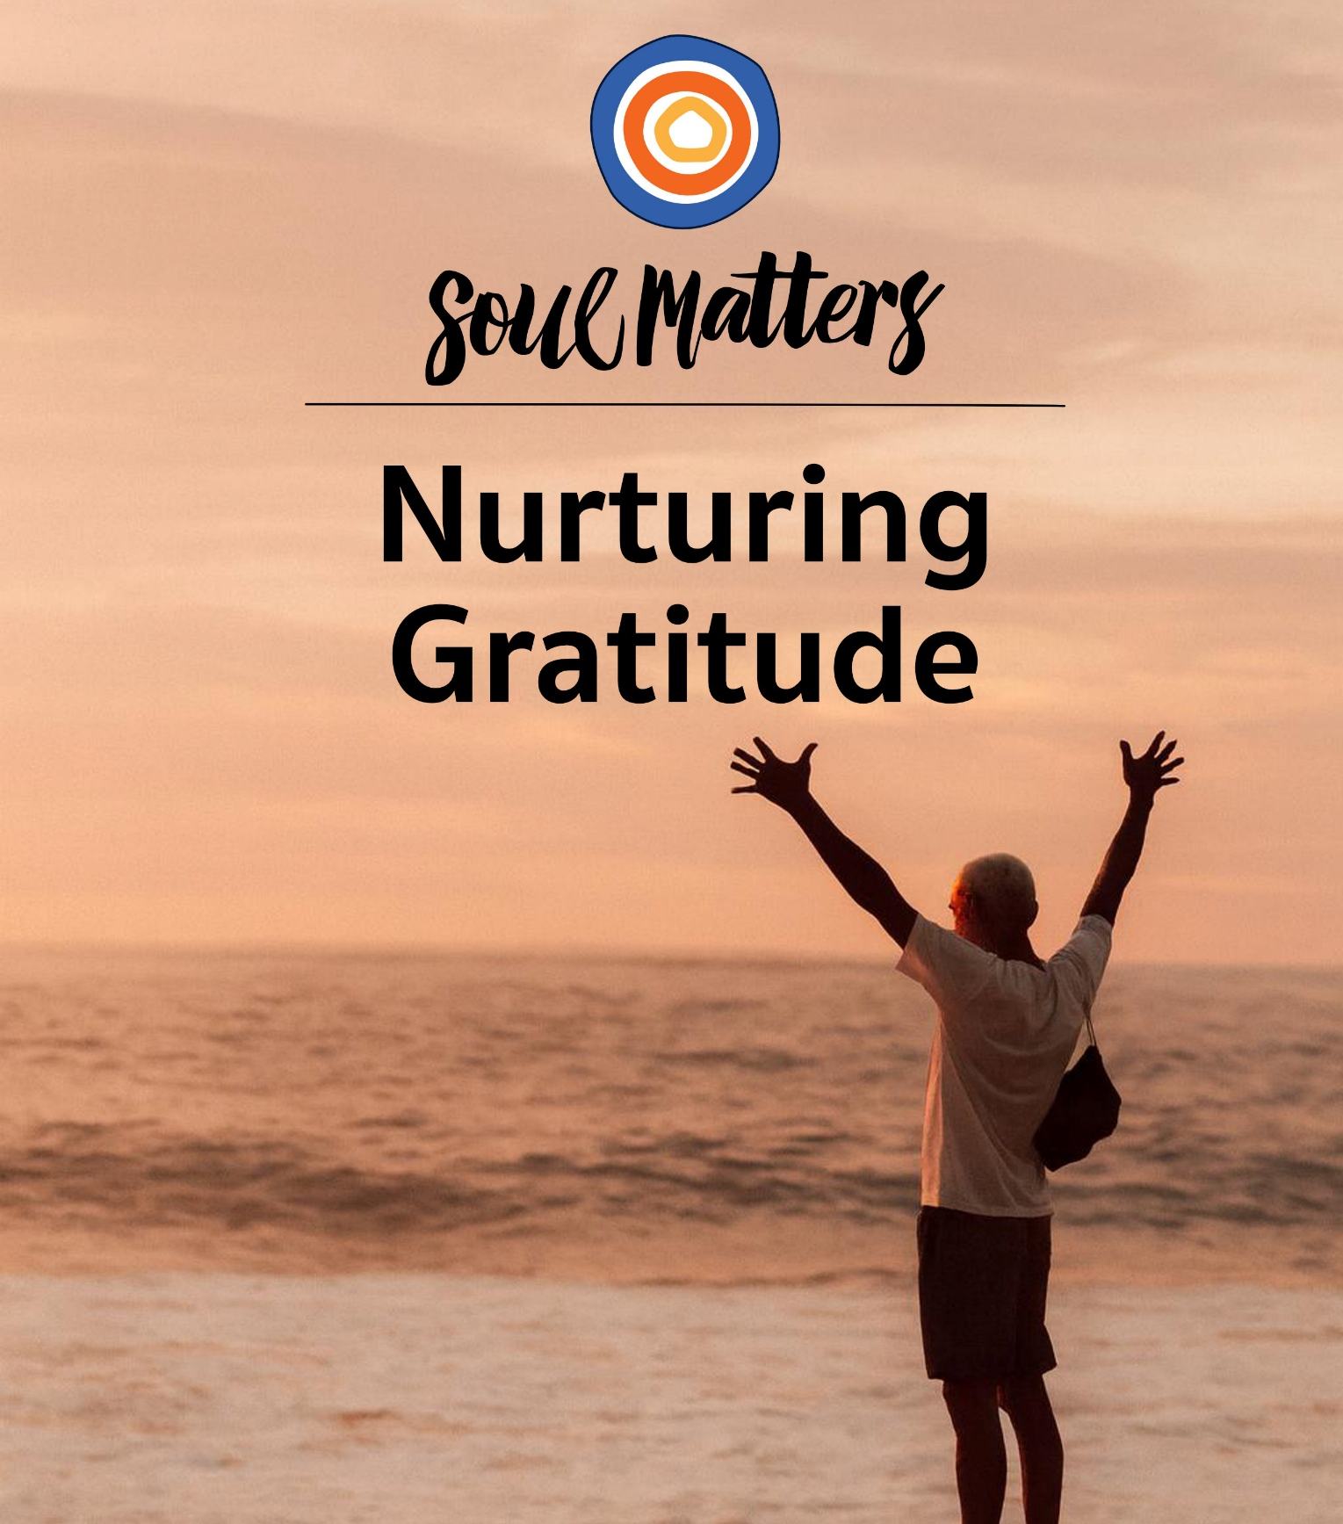
Soulful Journey  November 2025 | 

Welcome to Soulful Journey:

Nurturing Gratitude

When it comes to how we should travel through our lives, our culture and religion are clearly at odds. Culture cries, “Accumulate!” Religion counsels “Appreciate!” The mantras couldn’t be more different: The commercials surrounding us scream, “Go out and grab all you can!” The pulpits before us plea, “Learn to want what you have.”

There’s an important reminder here: Gratitude is essential. It’s not simply a nice “extra” to get around to when we can. Or to put it another way, we aren’t built for constant striving and the pursuit of more. Instead, we need moments of pause in which we are filled and replenished by the large and small wonders of this world. As poet and philosopher, Mark Nepo, puts it: “The original meaning of the word “appreciate” means to move toward what is precious. So, practicing gratitude reengages our aliveness—they awaken us to what is precious.” The implication here is clear: If we want to be truly alive, we need to pay attention when moments of gratitude arise.

But is that really it? Is that all we need to do? Wait for moments of gratitude to bloom and then stop and let their beauty sink in?

Many folks have their doubts. In one way or another, the voices within these pages point out that there is a big difference between appreciating the blessing of family and committing to sitting down together for dinner and intentionally sharing the blessings of one’s day. They go on to stress that it’s one thing to notice the beauty of nature; it’s quite another to pull yourself out of the rat race so you have time to enjoy it. And they certainly won’t let us forget that making a list of things we’re grateful for is impactful, but not nearly as powerful as the practice of “paying it forward.”

It’s all a way of gently pointing out that some of us practice gratitude passively and others actively. Or maybe the better way to put it is to say, gratitude needs our help! It can’t always flower all on its own, because there are serious threats out there: busyness, the lure of climbing the ladder, worries about the state of our world. They all work like weeds, suffocating and crowding out gratitude before it has a chance to sprout even the tiniest leaf.

Which means that maybe the most important part of this month’s theme is the "nurturing" part. Sitting back and waiting for gratitude to arise is simply not enough. That’s just not how gardens grow. If we listen carefully to the call of gratitude, we will hear a challenge to change our lives, not just appreciate them.

So, friends, as we weave our way through this month’s journey, may we carry with us the question of “What do I need to do a better job of noticing?” But may we also not forget the possibly even more important question of “What practices of weeding does gratitude need from me?”

And as we hold both of those questions tight, may the blooming begin!

Reflection and Journaling Questions

- When was the last time you were grateful for yourself?

- Which childhood experience are you most grateful for?

- Is there something you used to be grateful for that you now take for granted? What would it take to view it with fresh eyes?

- You are aware that your life is someone else’s dream, right?

- What would happen if you turned all of your “I have to’s” into “I get to’s”?

- How would your life change if you paused to reflect on how many things you have now that were things you only dreamt of a decade ago?

- How good are you at receiving thanks?

- Autumn leaves burn bright with color, but if you blink, they are gone. So, what temporary blaze of beauty do you need to give your gratitude and attention to before time runs out?

- Have you mistaken gratitude for a “feeling” rather than a practice? Or to put it another way, do you wait for gratitude to arise rather than proactively find ways to cultivate it?

- What wakes you up to the gift of it all?

- The most difficult gifts to be grateful for are the gifts given to us by our suffering and losses. Have you found the gift in the thing you wished hadn’t happened?

- So, life’s led you into a puddle. Are you still staring at your mud-covered feet? Or are you ready to look up and notice that the wide-open sky never went away?

- Might gratitude for your life increase if you lessened how much you compare it to the lives of others?

- How might gratitude be calling you to shift your thanks from what is extraordinary and rare to what is abundantly ordinary?
Recommended Resources for Personal Exploration & Reflection
The following resources are not required reading. Nor are they intended to be analyzed in your group.
Instead, they are here to companion you on your personal journey this month, get you thinking
and open you up to new ways of embodying this month’s theme in your living and loving.

Word Roots & Definitions

Gratitude has the same Latin root as kindness and grace. Its old English meaning was “a readiness to return kindness.” These connections invite us to think of gratitude as a way to usher more kindness into the world. Additionally, its connection to grace calls us to recognize what we receive from the world as a gift rather than as an entitlement.

Wise Words

The original meaning of the word “appreciate” means to move toward what is precious. Practicing gratitude is a type of leaning in towards being truly present. It’s a practice that reengages our aliveness—that awakens us to what is precious.
Mark Nepo

We enter the world as strangers who all at once become heirs to a harvest of memory, spirit, and dream that has long preceded us and will now enfold, nourish, and sustain us. The gift of the world is our first blessing.
John O'Donohue

It could happen any time, tornado, earthquake… Or sunshine, love, salvation… That’s why we wake and look out — no guarantees in this life. But some bonuses, like morning, like right now.
William Stafford

It’s not what we have that constitutes our abundance, but what we appreciate.
Jean Antoine Petit-Senn

Don’t misuse your mind. Don’t say there isn’t anything extraordinary here.
The Blue Cliff Record

So much has been given to me; I have no time to ponder over that which has been denied.
Helen Keller

Happiness does not make us grateful, gratefulness makes us happy.
David Steindl-Rast

Gratitude places you in the energy field of plenitude. Perceiving life in a consciousness of gratitude is literally stepping into another dimension of living. Suddenly the seeming ordinariness of your days takes on a divine sparkle.
Michael Beckwith

If our first response to the receipt of gifts is gratitude, then our second is reciprocity: to give a gift in return… When I speak about reciprocity as a relationship, let me be clear. I don’t mean a bilateral exchange in which an obligation is incurred, and can then be discharged with a reciprocal “payment.” I mean keeping the gift in motion in a way that is and diffuse, so that the gift does not accumulate and stagnate, but keeps moving.
Robin Wall Kimmerer, The Serviceberry

A hundred times every day I remind myself that my inner and outer life are based on the labors of others, living and dead, and that I must exert myself in order to give in the same measure as I have received and am still receiving.
Albert Einstein

Your normal day is someone else's dream.
Anonymous

Feeling gratitude and not expressing it, is like wrapping a present and not giving it.
William Arthur Ward

We should be especially grateful for having to deal with annoying people and difficult situations, because without them we would have nothing to work with. Without them, how could we practice patience, exertion, mindfulness, loving-kindness or compassion? It is by dealing with such challenges that we grow and develop. So we should be very grateful to have them.
Judy Lief
There is no wealth but life.
John Ruskin

If you find yourself… hearing, again, the earth's great, sonorous moan that says… all you love will turn to dust… Do not raise your small voice against it… Instead, curl your toes into the grass… Walk through the garden's dormant splendor. Say only, thank you.
Ross Gay

You will lose everything. Your money, your power, your fame, your success, perhaps even your memories… But that which will be lost has not yet been lost, and realizing this is the key to unspeakable joy… Impermanence has already rendered everything and everyone around you so deeply holy and significant and worthy of your heartbreaking gratitude. Loss has already transfigured your life into an altar.
Jeff Foster

When you are with someone who has developed the habit of gratitude, you SO want what they have. They are not grasping for more. They are savoring, shaking their heads slightly with the quietest wonder.
Anne Lamott

You wander from room to room, hunting for the diamond necklace that is already around your neck!
Rumi

Gratitude unlocks the fullness of life. It turns what we have into enough, and more. It can turn a meal into a feast, a house into a home, a stranger into a friend.
Melody Beattie

It is a slightly arresting notion that if you were to pick yourself apart with tweezers, one atom at a time, you would produce a mound of fine atomic dust, none of which had ever been alive but all of which had once been you. Yet somehow for the period of your existence they will answer to a single overarching impulse: to keep you you.
Bill Bryson

While we cry ourselves to sleep, gratitude waits patiently to console and reassure us that there is a landscape larger than the one we can see.
Sarah Ban Breathnach
With gratitude, optimism is sustainable. If you can find something to be grateful for then you can find something to look forward to, and you can carry on.
Michael J. Fox

The worst possible thing you can do when you’re down in the dumps, tweaking, vaporous with victimized self-righteousness, or bored, is to take a walk with dying friends. They will ruin everything for you.

Friends like this may not even think of themselves as dying, although they clearly are… No, they see themselves as fully alive. They are living and doing as much as they can, as well as they can, for as long as they can.

They ruin your multitasking high, the bath of agitation, rumination, and judgment you wallow in, without the decency to come out and just say anything. They bust you by being grateful for the day, while you are obsessed with how thin your lashes have become and how wide your bottom.
Anne Lamott

When eating a fruit, think of the person who planted the tree.
Vietnamese Proverb

Poetry

If the Moon Came Out Only Once a Month
Cathy Ross
If the moon came out only once a month
people would appreciate it more. They’d mark it
in their datebooks, take a walk by moonlight…
And if the moon rose but once a century,
ascending luminous and lush on a long-awaited night,
all humans on the planet would gather
in huddled, whispering groups…
Tonight
why not go outside and gaze up in wonder,
as if you’d never seen it before,
as if it were a miracle,
as if you had been waiting
all your life.

Full poem at https://www.graceguts.com/poems-by-others/if-the-moon-came-out-only-once-a-month
The Fountain
Denise Levertov
“Don’t say, don’t say there is no water
to solace the dryness at our hearts.
I have seen the fountain springing out of the rock wall
and you drinking there. And I too…”

Full poem at https://poethead.wordpress.com/2008/06/10/the-fountain-by-denise-levertov/

Butter
Tony Hoagland
I think it was Marie who first taught me the art
of spreading flattery on people
then smearing it around like marmalade on slabs of whole wheat bread,
or how to spray them lightly with a mist of unexpected praise…
Why did it take me so long to see that the power of sweetness
is as great as the power of the river and the sun?
If I can’t improve the world by scorching it with truth…
I will lavish the world with the power of butter.
I will force it to feel good about itself.
First I will make it blush—
then I will step back, and watch it shine.

On the practice of “smearing thanks” and appreciation and then “watching the world shine.”
https://afirstsip.substack.com/p/butter?utm_source=publication-search

Communion At The BP
Paula Gordon Lepp
…And I couldn’t help but wonder
how many times I have denied
someone the blessing of serving
because I have been too stubborn
to accept their gift.

As I was standing there in
the sun-drenched gas station
parking lot, the hiss and tick of
the air pump sounded very much
like a psalm…

Full piece at https://braidedway.org/communion-at-the-bp/

Meditations & Prayers

All the holy nudges that we need… *
Rev. Dr. Rebekah Savage

Spirit of Life, Eternal Beloved of Mystery and Grace;
Receive our prayer:
We come before That Which is Greater than ourselves in gratitude for the fullness of our lives.
For the anguish and grief that informs our mission to Side with Love again and again.
For the suffering and disenfranchisement of our people that foments our passion for Justice and wholeness.
For complex lives, for hard lives, for real, full and overwhelmed lives, we give thanks for the blessings that we have been given: the reassurance of community, the steady warmth of hope, and the unwavering faith that There will be better days.
We give thanks and seek your grace.
Spirit of Love, come alongside with all the holy nudges that we need,
So we may live in such a way that we celebrate all the blessings that we have been given.
So we may Be the blessings in the world.

Prayer of Praise and Thanks *
Rev. Tess Baumberger

Oh Divine Spirit, healer of our hurts, consoler of our sorrows, vibrant light of happiness, birther of all life and gentle way of death, hear our prayer.

We raise our hearts to you as do the ancient redwoods,
rooted in the ground, swaying in the wind.

We praise and thank you for our lives, gifts of body and essence, strength to bear life's burdens, grace to dance life's joys.

We praise and thank you for our lives, gifts of eyes and heart that fill with beauty smiling, or with pain and sadness weeping.

We praise and thank you for our lives, gifts of ears to hear words of grace and wisdom, to listen to and lighten the burdens of others.

We praise and thank you for our lives, our voices to sing out praises,
to speak my truths and visions, to share ourselves with others.

We praise and thank you for our lives, gifts of all my senses, rhythm of our heartbeat, rise and fall of our breathing, the will to live with passion, serenity, joy.

Spirit, guide us to a deeper knowing of your presence in the world.
Show us the fuller meanings of the patterns of our years.
Help us regard ourselves and others with eyes of calm compassion.
Teach us to learn patience with their failings and our own.
Help us accept the mold and fashion of our lives through marching years.

In the names of all who perceive your transcendent presence
in trees and brooks and mountains, in work and play and resting,
in all moments and places between, amen and blessed be.

For Those Who Came Before *
Rev. Michelle Collins

Holy Stillness, we sit in the shade of trees we did not plant, speak with voices shaped by languages we did not create, breathe free air that others died to protect. Every freedom we exercise, every opportunity we pursue, every moment of safety we enjoy carries the fingerprints of those who came before.

We remember ancestors of blood and choice, known and unknown, who endured hardships we can barely imagine so we might inherit possibilities they could only dream. We carry forward the hopes of enslaved people who chose love over bitterness, immigrants who crossed oceans for children they would never meet, activists who planted seeds in ground too hard for them to see bloom.

Their struggles live in our bodies, their dreams in our daily choices, their unfinished work in our hands. May we honor their sacrifices not through nostalgia but through action, not through guilt but through gratitude that moves our feet toward justice.

Help us become ancestors future generations will thank, planting trees whose shade we'll never rest in, fighting battles whose victories we won't live to see, loving this world forward with the same fierce hope that brought us here.

For What Shall We Give Thanks? *
Rev. Laura Horton-Ludwig

The wheel of the year has turned again.
Once more the Thanksgiving season has arrived.
How shall we sing our song of gratitude now?
For what shall we give thanks?

For this moment;
for friends near and far;
for our breath;

for love;
for courage and clarity;
for strength;
for delight;
for laughter;
for beauty;

for the tables round which we gather;
for the food we enjoy with friends,
seasoned with love and memory;

for the sun and moon and stars in the sky;
for the trees who have seen so much
and still stand proud, stretching themselves to the sky;

for the bright voices of children;
for the wisdom of elders;
for actions that bless the world;
for hard work that makes a difference;

for music and art and celebration;
for generosity;
for compassion;
for endurance;
for joy;
for hope.

For all these things, we give thanks.

Buddhist Daily Prayer

With gratitude we remember the people, animals, plants, insects, creatures of the sky and sea, air and water, fire and earth, all whose joyful exertion blesses our lives every day.
With gratitude we remember the care and labor of a thousand generations of elders and ancestors who came before us.
We offer my gratitude for the safety and wellbeing we have been given.
We offer my gratitude for the blessing of this earth we have been given.
We offer my gratitude for the measure of health we have been given.
We offer my gratitude for the family and friends we have been given.
We offer my gratitude for the community we have been given.
We offer my gratitude for the teachings and lessons we have been given.
We offer my gratitude for the life we have been given.

Let Us Give Thanks
Rev. Max Coots

Let us give thanks:
For generous friends…with hearts as big as hubbards and smiles as bright as their blossoms;
For feisty friends as tart as apples;
For continuous friends, who, like scallions and cucumbers, keep reminding us we had them;
For crotchety friends, as sour as rhubarb and as indestructible...

Full piece at https://thesalemgarden.com/2014/11/26/let-us-give-thanks/ & https://emilierichards.com/2013 /11/24/sunday-inspiration-let-us-give-thanks-for-a-bounty-of-people/

Gratitude *
Swiftwalker

…Let what wisdom we have,
wan and wanting, lead us to
strive so the seventh generation
hence can live more fully.
It is in that work, and that alone,
that we can express our thankful spirit.

Full piece at http://www.uua.org/worship/words/poetry/gratitude

The Chalice of Our Being *
Rev. Richard Gilbert

Each morning we hold out our chalice of being
To be filled with the graces of life that abound—
Air to breathe, food to eat, companions to love…
We give back in gratitude if we can
Something like what is poured into our chalice of being—
For those who abide with us and will follow.
Each morning we hold out the chalice of our being,
To receive, to carry, to give back.

Full piece at https://www.uua.org/worship/words/meditation/chalice-our-being

Sabbath Home
Rev. Kathleen McTigue

…Even in our sorrows, we feel our lives
cradled in holiness we cannot comprehend…
Into this home we bring the courage to walk on after hard losses.
Into this home we bring our joy,
and gratitude for ordinary blessings.
By our gathering we bless this place.
In its shelter we know ourselves blessed.

Full piece found in Shine and Shadow, pg. 48, UUA meditation manual & Soul Matters “Common Shelf” book.

Gratitude Blessing
Christine Valters Paintner

Spirit of Generosity,..
As we awaken each morning,
help us to remember
this day is a gift,
this breath is grace,
this life a wonder.
Remind us
with every flower we see,
every act of kindness,
every moment of connection…
to whisper thank you…

Full piece found at https://mailchi.mp/abbeyofthearts/sabbath-and-generosity-aug17-2025?e=01aedcb1aa

Thanksgiving for Creation*
Rev. Tess Baumberger

We gather this morning to say “thank you” from our hearts for all the blessings of our lives.
I invite you to respond with the words “Let us give thanks.”

For the beauty of the sun
And the moon and the stars
For clouds and the wide blue sky

Let us give thanks

For the trees and the mountains,
Prairies, deserts and valleys,
For lakes, oceans and rivers,

Let us give thanks

For birds, fish, bugs,
All creatures of the earth and sky,
And especially for our animal friends

Let us give thanks

For all people of all genders,
Of every race, of every country, of every religion
No matter who they love or who they voted for…

Let us give thanks

For the kindness we find in our own hearts, and
In the hearts others we meet each day.

Let us give thanks

For the joy of being here together today,
Old and new, friend and stranger, gathered in this place.

Let us give thanks

A Guided Meditation on Gratitude
Rev. Susan Frederick-Gray, past UUA President
https://www.youtube.com/watch?v=FMwCIqOVELc
Prayer for Our Trancestors (Transgender Day of Remembrance, Nov. 20)
Laura Conkle

We love and remember our trans siblings stolen from us this year. We love and remember all of our trancestors stolen from us throughout time and space.
Our hearts are broken. May we find the care in our community to keep grieving and keep loving and keep living.

Let us pray:
Life, Soul, Love ~ We call out to you in our grief and our rage. We call out to you in our terror and our exhaustion. Please help us to gather ourselves together and to each other. Give us strength. Give us comfort. Give us care…

Full piece found at https://www.uua.org/worship/words/prayer/prayer-our-trancestors

A Thanksgiving Blessing *
Rev. Naomi King

Let us join and hands and hearts in gratitude on this wondrous day where we have the abundance of our lives before us. We remember on this day of bounty, all of those who do not have enough, who are afraid, who are lonely, and who suffer. We wish for the abundance of this world to be shared…

Full piece found at http://www.uua.org/worship/words/meditation/184352.shtml

Books & Articles

The Unlikely Pilgrimage of Harold Fry
Rachel Joyce

The Serviceberry: Abundance and Reciprocity in the Natural World
Robin Wall Kimmerer

Wake Up Grateful: The Transformative Practice of Taking Nothing for Granted
Kristi Nelson

Catalog of Unabashed Gratitude
Ross Gay

Returning the Gift, Robin Wall Kimmerer
On Indigenous Wisdom and Gratitude
https://grateful.org/resource/returning-the-gift/

A Thanksgiving Message from Seven Amazing Native Americans
https://www.project562.com/blog/a-thanksgiving-message-from-seven-amazing-native-americans

Videos & Podcasts

Because… Andrea Gibson
https://www.instagram.com/reel/C9ISC0kOrW6/

Just pause and ask yourself… Trevor Noah
https://www.instagram.com/thoughtsmagnet/reel/DC-cB9TyEQv/

Blessing For Sound and Light, David Whyte
https://vimeo.com/639146289?embedded=true&source=video_title&owner=1022824

The Gratitude Time Machine Practice
https://www.instagram.com/p/C6uYo9dojcP/

On Gratitude as Our Guide Through Grief
https://www.youtube.com/watch?v=l860_0ZBhb4

What Punishments of God are not Gifts?, Stephen Colbert
https://www.instagram.com/p/DFs03uxOCsC/

Confessions on Gratitude, Jonathan Mendoza
https://www.youtube.com/watch?v=MUHHVKU_L9A

Grateful Voices, Claire
https://www.youtube.com/watch?v=qircCsSHO7A

Thank You, Ross Gay
https://www.tiktok.com/@moongladecommons/video/7498759145743502638

Thanks, W.S. Merwin
https://www.instagram.com/reel/DNBUfQjsbNv/

On Ordinary Gifts & Gratitude for All of Life
https://www.youtube.com/watch?v=jNVPalNZD_I

Acceptance Speech after Setting the World Record in Goosebumps, Andrea Gibson
https://www.youtube.com/watch?v=4XK-hb_bjqU

More of This - The Sanctuary Boston
https://www.youtube.com/watch?v=rDZ7ug1eEzU

Music
- Spotify playlist on Nurturing Gratitude
- YouTube playlist on Nurturing Gratitude
- “In My Life” by The Beatles
- “Thank U” by Alanis Morrisette
- “Grateful” by Rita Ora
- “Kind and Generous” by Natalie Merchant
- “Thankful” by Celine Dion
- “Gratitude” by Earth, Wind, and Fire
- “Thank You” by Dido
- “Thank You For Being A Friend” by Andrew Gold

Movies
- The Life of Chuck
- A Man Called Ove
- Gratitude Revealed
- Forrest Gump
- The Gift


© 2025-26 Soul Matters ALL RIGHTS RESERVED
Packets are for use ONLY by member congregations of the Soul Matters Sharing Circle.
Learn how to join at https://www.soulmatterssharingcircle.com

