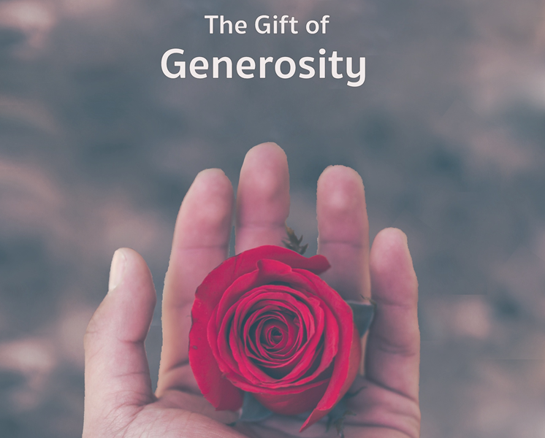

We make a living by what we get,
we make a life by what we give.
Author unknown

Monthly Theme Resources  November 2023 | 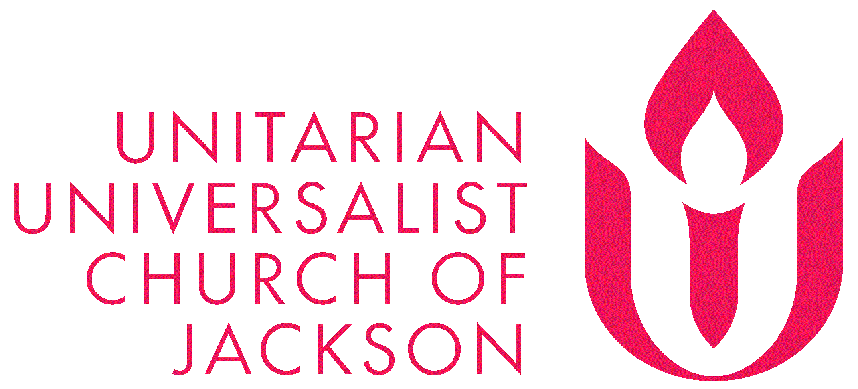

Calendar Connections: November 2023
Month | Native American Heritage Month  Alzheimer's Awareness Month
Oct 31 – Nov 1 | Samhain (Wiccan, more here)
Oct 31 – Nov 2 | Día de Los Muertos/Day of the Dead
Nov 1 | All Saints Day (Christian, more here)
Nov 2 | All Souls Day, more here and here)
Nov 6 | James Weldon Johnson & J. Rosamond Johnson composed "Lift Ev'ry Voice and Sing" (1900)
Nov 7 | U.S. Elections
Nov 8 | Birthday of Dorothy Day (1897)
Nov 11 | Veterans Day
Nov 12 | Diwali: Festival of Lights (Hindu) starts on - Starts Nov. 12. 2023
Nov 12 | James Luther Adams birthday [more]
Nov 13 | U.S. Supreme Court ruled racial segregation on public buses was unconstitutional (1956)
Nov 13 | World Kindness Day
Nov 15 | Francis David died in prison (1579) Learn more here
Nov 20 | Transgender Day of Remembrance
Nov 23 | National Day of Mourning / Thanksgiving Day
Nov 24 | Evolution Day Anniversary of the publishing of Origin of Species (1859)

Recommended Resources for Personal Exploration & Reflection

Wise Words

I have lived with passion and in a hurry... until my 28-year-old daughter Paula fell ill. She was in a coma for a year, and I took care of her at home, until she died in my arms. Paralyzed and silent in her bed, my daughter Paula taught me a lesson that is now my mantra: You only have what you give… The pain of losing my child was a cleansing experience. I had to throw overboard all excess baggage and keep only what is essential. Because of Paula, I don't cling to anything anymore. Now I like to give much more than to receive… what is the point of having experience, knowledge or talent if I don't give it away? …I don't intend to be cremated with any of it! It is in giving that I connect with others, with the world and with the divine. It is in giving that I feel the spirit of my daughter inside me, like a soft presence.
Isabel Allende

Attention is the rarest and purest form of generosity.
Simone Weil

We make a living by what we get, we make a life by what we give.
Author unknown

A student went to his master and said, “I am very discouraged. What should I do?” The Zen Master replied, “Encourage others.”
Nakagawa Roshi

When we are feeling the poorest, that’s the time to give a gift.
Dhyani Ywahoo

Until we can receive with an open heart, we’re never really giving with an open heart. When we attach judgment to receiving help, we knowingly or unknowingly attach judgment to giving help.
Brene Brown

We are cups, constantly and quietly being filled. The trick is, knowing how to tip ourselves over and let the beautiful stuff out.
Ray Bradbury

Gracious acceptance is an art – an art which most never bother to cultivate. We think that we have to learn how to give, but we forget about accepting things, which can be much harder than giving…. Accepting another person’s gift is allowing them to express their feelings for you.
Alexander McCall Smith

I have found that among its other benefits, giving liberates the soul of the giver.
Maya Angelou

The religious person is the grateful person. The grateful person is the generous person.
Rev. Don Wheat

Daily I am astonished at how readily I believe that something I need is in short supply. If I hoard possessions, it is because I believe that there are not enough to go around. If I struggle with others over power, it is because I believe that power is limited. If I become jealous in a relationship, it is because I believe that when you get too much love, I will be shortchanged... The irony, often tragic, is that by embracing the scarcity assumption, we create the very scarcities we fear. If I hoard material goods, others will have too little, and I will never have enough... If I get jealous of someone I love, I am likely to drive that person away.
Parker Palmer

If we cultivate generosity, the mind will stop sticking to things. It’s as if we’ve made a tight fist that is slowly opening… Our world opens up because we can let go.
Sharon Salzberg

Generosity is not a down-payment on love.
Netta

All you are unable to give possesses you.
Andre Gide

Too many have dispensed with generosity in order to practice charity.
Albert Camus

If we are prepared to interrogate our privilege, we will conclude that philanthropy is not only about giving back, but it may be also giving up something, so that we can have an America where opportunity does exist for all.
Darren Walker

If today’s church does not recapture the sacrificial spirit of the early church, it will lose its authenticity, forfeit the loyalty of millions, and be dismissed as an irrelevant social club with no meaning
Martin Luther King

I tell my students, 'When you get these jobs that you have been so brilliantly trained for, just remember that your real job is that if you are free, you need to free somebody else. If you have some power, then your job is to empower somebody else. This is not just a grab-bag candy game.”
Toni Morrison

If the landscape reveals one certainty, it is that the extravagant gesture is the very stuff of creation. After the one extravagant gesture of creation in the first place, the universe has continued to deal exclusively in extravagances, flinging intricacies and colossi down eons of emptiness.
Annie Dillard

Charity is about helping people survive. Justice is about helping people thrive.
Laura Arrillaga-Andreessen
Poetry

Meanwhile the day is beautiful
for everyone, no matter how broken… our hearts…
It gathers us all
in a grand blue embrace.
Part of me resists calling it a miracle.
The other part calls it what it is
and strolls through the miracle
of Friday morning surrounded by arugula
and strawberries, muffins, lilies,
and all these other fragile hearts…
Rosemerry Wahtola Trommer

And we pray, not
for new earth or heaven, but to be
quiet in heart, and in eye
clear. What we need is here.
Wendell Berry

Videos & Podcasts

Decolonizing Wealth
https://www.youtube.com/watch?v=LKHmU95w_Q8
Related book

Just Giving: Why Philanthropy Is Failing Democracy
https://www.youtube.com/watch?v=uKC6qxZNsSk
Related book

The Art of Asking (for generosity)
Amanda Palmer
https://www.youtube.com/watch?v=xMj_P_6H69g
Are You a Giver or a Taker? TED Talk
Adam Grant
https://www.youtube.com/watch?v=YyXRYgjQXX0&t=274s

Will AI be a generous gift to humanity or a trojan horse?
https://munkdebates.com/podcast/munk-debate-on-artificial-intelligence

Article

People Are More Generous Than You May Think, David Brooks
https://www.nytimes.com/2023/08/31/opinion/human-nature-good-bad-generous.html

How Giving Leads to Receiving, Andrew Quagliata
https://www.andrewquagliata.com/post/the-power-of-reciprocity-how-giving-leads-to-receiving

Books

Why Good Things Happen to Good People: How to Live a Longer, Healthier, Happier Life by the Simple Act of Giving
Jill Neimark, Stephen Post

Just Giving: Why Philanthropy Is Failing Democracy and How It Can Do Better
Rob Reich
Extended excerpt: https://press.princeton.edu/ideas/a-look-inside-just-giving

Music

Two different playlists for each of our monthly themes: one in Spotify and another in YouTube. They are organized as a journey of sorts, so consider listening from beginning to end and using the playlists as musical meditations.

Click here for the Spotify playlist on Generosity
Click here for all Spotify playlists.
Click here for the YouTube playlist on Generosity
Click here for all the YouTube playlists.

Movies & TV
Somebody, Somewhere. A moving series about being held and transformed by the generosity of friendship. Sam, a true Kansan on the surface, struggles to fit her hometown's mold; grappling with loss and acceptance, singing is her saving grace and leads her on a journey to discover herself and a community of outsiders who don't fit in and don't give up. | 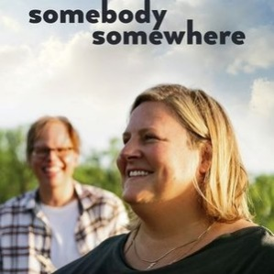
Millions. A charming children fable even adults can enjoy. When 9-year-old Damian (Alex Etel) finds a bag of money in his back yard, he and his brother Anthony (Lewis Owen McGibbon) decide to try to spend it without telling their father (James Nesbitt). Seeking advice from the imaginary saints, Damian struggles with his own morality, and attempts to spend his money in a more altruistic way. News of the mysterious loot attracts attention, and Damian is faced with an increasingly hairy situation. | 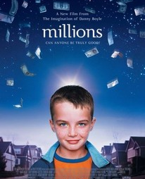
The Blue Umbrella (short film)  On how life generously helps us on our way and picks us up when we are down. Amidst the rain in a singing city, two umbrellas - one blue, one not - fall eternally in love (imdb.com) | 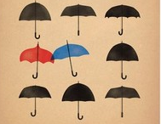
I, Daniel Blake. Daniel Blake (Dave Johns) is a 59-year-old widowed carpenter who must rely on welfare after a recent heart attack leaves him unable to work. Despite his doctor's diagnosis, British authorities deny Blake's benefits and tell him to return to his job. As Daniel navigates his way through an agonizing appeal process, he begins to develop a strong bond with a destitute, single mother (Hayley Squires) who's struggling to take care of her two children. | 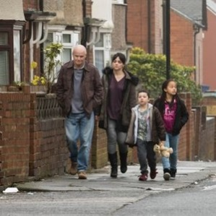
The Way We Get By. This documentary chronicles a group of tireless senior citizens who devote their time to comforting U.S. troops returning from Iraq and Afghanistan. At an airport in Bangor, Maine, the retirees turn out when an airplane carrying an American soldier arrives, providing the young men and women with meals, cell phones to call home and rounds of applause. The film also explores the home lives of the seniors. | 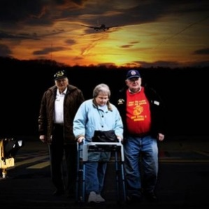
Please Give. Kate (Catherine Keener) and her husband Alex (Oliver Platt) are wealthy New Yorkers who prowl estate sales and make a tidy profit reselling items they bought cheaply. They buy the apartment next door and plan to remodel when its tenant, a cranky old woman, dies. Kate is troubled by the way she and her husband earn a living, and tries to assuage her guilt by befriending her tenant and the woman's granddaughters. Her overtures lead to unexpected consequences. | 
Movie descriptions were extracted from Rottentomatoes.com unless otherwise noted. All images were downloaded from Rottentomatoes.com.
Reflection Questions

Don’t treat these questions like “homework” or try to answer everyone. Instead, make time to meditate on the list and then pick the one question that speaks to you most. The goal is to figure out which question captures the call of your inner voice? Which one contains “your work”? And what is that question trying to get you to notice or acknowledge?

Often it helps to read the list to a friend or loved one and ask them which question they think is the question you need to wrestle with!

- How has your definition of generosity changed since you were younger?
- How has your enjoyment of generosity changed since you were younger?
- Who taught you the most about being a generous person?
- Has being generous ever led to you becoming “richer”?
- Has generosity ever healed you?
- What’s been your hardest act of generosity?
- Have you ever wished your parent(s) had been more generous in some way?
- How might Life be calling you to be generous in a new way in your closest relationships?
- Without knowing it, we all put boundaries and limits around our generosity. How might the storylines and beliefs passed on to you by your family or society be hemming in what you have to give to the world?
- Do you have trouble giving yourself permission to receive the generosity or help of others? What storyline might be hemming in your ability to receive that generosity?
- Some say that attention is the rarest and purest form of generosity. Who needs the gift of your attention?
- Some say that giving liberates and frees the giver. How might Life be trying to free you by asking you to give?
- What if the secret is giving to others what we wish to receive ourselves?
- How good are you at being generous with yourself?

What’s your question? Your question may not be listed above. As always, if the above questions don't include what life is asking from you, spend the month listening to your days to find it.

Meditations, Prayers, & Blessings
[An asterisk (*) marks permissioned for online use.]

The Chalice of Our Being * (Permission Source)
Rev. Richard S. Gilbert
Full piece at https://www.uua.org/worship/words/meditation/chalice-our-being

Each morning we hold out our chalice of being
To be filled with the graces of life that abound…

We share its abundance if we have any sense,
Reminding others as we remind ourselves
Of the contents of the chalice we don’t deserve.
Water from living streams fills it
If only we hold it out faithfully…

Choose to Bless the World * (Permission Source)
Rev. Rebecca Ann Parker
Full piece at https://www.uua.org/worship/words/blessing/choose-bless-world

You must answer this question:
What will you do with your gifts?
Choose to bless the world.
The choice to bless the world is more than an act of will…
It is an act of recognition,
a confession of surprise,
a grateful acknowledgment
that in the midst of a broken world
unspeakable beauty, grace and mystery abide.

When Giving Is All We Have
Alberto Ríos
Full poem at https://poets.org/poem/when-giving-all-we-have

“...You gave me blue and I gave you yellow.
Together we are simple green. You gave me

What you did not have, and I gave you
What I had to give—together, we made

Something greater from the difference.”

Prayers and Dreamings
Rev. Becky Edminston-Lange
Full piece found in Falling into the Sky (pg. 36), UUA worship resource/Soul Matters “Common Shelf”

… fill us with such love for this holy creation…
that we might claim our inheritance and live our calling
to bless the world and each other with our care. Amen

Autumn
Rev. Ann Willever
Found in Falling into the Sky, UUA worship resource/Soul Matters “Common Shelf”

all the holy nudges that we need… * (Permission secured by Soul Matters)
Rev. Dr. Rebekah Savage

Spirit of Life, Eternal Beloved of Mystery and Grace;
Receive our prayer:
We come before That Which is Greater than ourselves in gratitude for the fullness of our lives.
For the anguish and grief that informs our mission to Side with Love again and again.
For the suffering and disenfranchisement of our people that foments our passion for Justice and wholeness.
For complex lives, for hard lives, for real, full and overwhelmed lives, we give thanks for the blessings that we have been given: the reassurance of community, the steady warmth of hope, and the unwavering faith that There will be better days.
We give thanks and seek your grace.
Spirit of Love, come alongside with all the holy nudges that we need,
So we may live in such a way that we celebrate all the blessings that we have been given.
So we may Be the blessings in the world.

A Thanksgiving Blessing * (Permission Source)
Rev. Naomi King
Full piece at http://www.uua.org/worship/words/meditation/184352.shtml

Let us join and hands and hearts in gratitude on this wondrous day where we have the abundance of our lives before us. We remember this day of bounty all of those who do not have enough, who are afraid, who are lonely, and who suffer. We wish for the abundance of this world to be shared, for fear to become love, for the lonely to feel welcomed, and for the suffering to know rest and joy. For the labors, the love, the care that gave us the delights of this and every day, we say "thanks!" For the nourishment of our spirit, the challenges that strengthen us, and the friends we have on the journey, we sing "thanks!" For all that is our lives, for these good gifts, we whisper, "thanks!" Overflowing with gratitude, let us shout, "thanks!" Amen.

Transgender Remembrance Prayer - UU
Rev. Theresa Ninán Soto
Full piece at https://www.transformingheartscollective.org/stories/prayers-for-transgender-justice

Spirit of Life…
We know that you know that transness is life and that You accept us and all the ways that we are, not as part of being human but as a multiplicity of expressions of love…
Soften the hearts of those who are causing their own suffering by clutching their transphobia so tightly. Show them the way back to their own humanity…

Transgender Day of Remembrance Prayer * (Permission Source)
Rev. Sunshine Jeremiah Wolfe
Full piece at https://www.uua.org/worship/words/prayer/transgender-day-remembrance-prayer

…May we come to a time when we cease to shame children around gender roles and expression,
where we allow for freedom and exploration of identity and expression,
and to a world that operates from love

Stories For All Ages

Picture Books

The Circles All Around Us, Brad Montague
Book: https://www.amazon.com/Circles-All-Around-Us/dp/0593323181
Read-Aloud: https://www.youtube.com/watch?v=BoGglWsVhPY (to min. 3:22)
Circles in Circles For All Ages (Jenni Papp, DRE): https://www.youtube.com/watch?v=2F9egUX1wt4

Everything is Connected, by Jason Gruhl

Book: https://www.amazon.com/Everything-Connected-Jason-Gruhl/dp/1611806313/
Read-Aloud: https://www.youtube.com/watch?v=UcCJ3_d85eE

The Table Where Rich People Sit, by Byrd Baylor
Book: https://www.amazon.com/Table-Where-People-Aladdin-Picture/dp/0689820089/
Read-Aloud: https://www.youtube.com/watch?v=u8Plzn1-WaQ

What is Given From the Heart, Patricia C. McKissack
Book: https://www.amazon.com/What-Given-Heart-Patricia-McKissack/dp/0375836152/
Read-Aloud: https://www.youtube.com/watch?v=0T-e92dHQcI (start at min. :59)

The Starkeeper by Faith Pray
Book: https://www.amazon.com/Starkeeper-Faith-Pray/dp/1984892703/
Read-Aloud: https://www.youtube.com/watch?v=PI0IIEFlVaU

Tellable Tales

Stone Soup
https://www.youtube.com/watch?v=P_TXIoiuBd4
https://www.learningtogive.org/sites/default/files/handouts/Story_Stone_Soup.pdf

The Umbrella Sanctuary, Tim Atkins
https://www.uua.org/worship/words/story/umbrella-sanctuary

Sophia's Guest, Becky Brooks
https://www.uua.org/worship/words/story/sophias-guest

The Good Samaritan (Luke 10:25 - 37)
https://www.biblegateway.com/passage/?search=Luke%2010%3A25-37&version=NIV

Heaven and Hell
https://www.uua.org/re/tapestry/children/toolbox/session1/heaven-hell

The Moon Cannot Be Stolen (Zen Koan or Story)
https://www.101zenstories.info/p/9-moon-cannot-be-stolen.html

How Much Does a Snowflake Weigh?, Tapestry of Faith: Amazing Grace
https://www.uua.org/re/tapestry/children/grace/session15/snowflake

