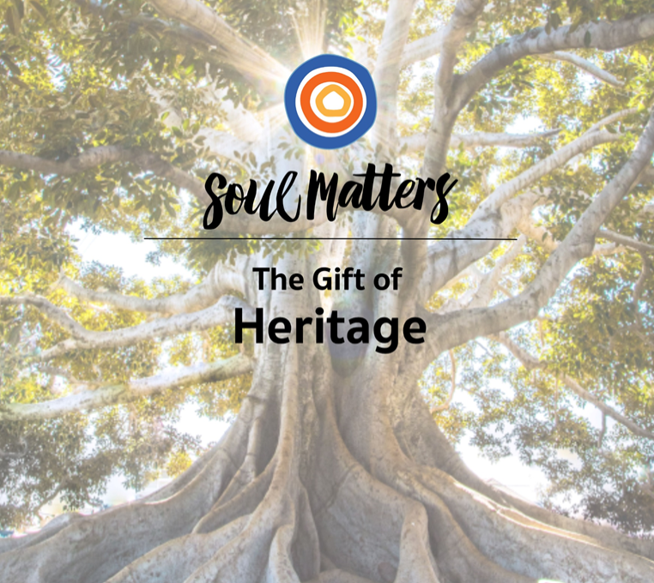

Our heritage calls,
echoing voices,
urging love,
summoning joy.
-- Rev. David Breeden
Monthly Theme Resources  October 2023 | 

Calendar Connections: October 2023
Month | LGBTQ History Month  Breast Cancer Awareness Month  Bullying Prevention Month  ADHD Awareness Month  Country Music Month (designated Oct. 1970 by Richard Nixon) more here
Sept. 15-  Oct. 15 | Hispanic Heritage Month
Sept. 29-  Oct. 6 | Sukkot: Feast of Tabernacles (Jewish)
Oct. 1 | World Vegetarian Day
Oct. 1 | World Communion Sunday (Christian)
Oct. 1-7 | Banned Books Week, more here
Oct. 2 | Birthday of Mohandas Gandhi (1869)
Oct. 2 | Thurgood Marshall sworn in - first African American associate justice - U.S. Supreme Court – (1967)
Oct. 4 | Sisters in Spirit Vigils (Canada, 2018): Honoring the lives of Missing and Murdered Indigenous Women and Girls (MMIWG)
Oct. 4 | Feast of St Francis of Assisi (Christian)
Oct. 4 | Ruth Bader Ginsburg joins the U.S. Supreme Court as 2nd woman Justice (1993)
Oct. 6 | World Smile Day
Oct. 8 | Clergy Appreciation Day 2023 (2nd Sunday)
Oct. 9 | Indigenous Peoples Day [Columbus Day] (U.S., 2nd Monday), more here
Oct. 11 | National Coming Out Day, more here
Oct. 11 | NASA launches first peopled mission, Apollo 7 (1968)
Oct. 14 | Birthday of e e cummings
Oct. 24 | United Nations Day
Oct. 26 | Intersex Awareness Day
Oct. 27 | Michael Servetus burned at the stake in Geneva (1553), more here
Oct. 31 | Samhain (Wiccan), more here and here
Oct. 31 | Halloween, All Soul's Eve
Oct. 31 | Reformation Day (Christian), more here
Oct. 31 | UU Merger Vote: Unitarians and Universalists, meeting separately in Syracuse, NY, voted to proceed with consolidation (1959)  The official consolidation, UUA Founding Day, happened in 1961 on May 12. More here.

Recommended Resources for Personal Exploration & Reflection

Wise Words

The past is never dead. It's not even past.
William Faulkner

Some people are your relatives, but others are your ancestors, and you choose the ones you want to have as ancestors. You create yourself out of those values.
Ralph Ellison

In times like these, I look to the past. I come from people not meant to survive, and here is our bloodline, stronger than ever.
Brittany Packnett

​When a society or a civilization perishes, one condition can always be found. They forgot where they came from.
Carl Sandburg

When heritage becomes a box instead of an inspiration, it has gone too far.
Brandon Sanderson

When we lie about the past, we steal from the future.
Abigail Bengson

My father used to say that stories are part of the most precious heritage of humankind.
Tahir Shah

History doesn’t repeat itself, but it does rhyme.
Mark Twain

The Dead are our nearest neighbors.
John O’Donohue

We are a collage—a remix—of our ancestors. We have spiritual DNA, as well as physical, and our lot in life is to answer the questions posed by the people who came before us.
Austin Kleon

I became aware of the fateful links between me and my ancestors. I feel very strongly that I am under the influence of things or questions which were left incomplete and unanswered by my parents and grandparents and more distant ancestors... It has always seemed to me that I had to answer questions which fate had posed to my forefathers, and which had not yet been answered, or as if I had to complete, or perhaps continue, things which previous ages had left unfinished.
Carl Jung

Walking. I am listening in a deeper way. Suddenly all my ancestors are behind me. Be still, they say. Watch and listen. You are the result of the love of thousands.
Linda Hogan

To acknowledge our ancestors means we are aware that we did not make ourselves.
Alice Walker

Whereas history pleads, “Protect what we put into place!” Heritage urges, “Know the plotline of which you are a part.” History is what happened; Heritage is a story still unfolding. History tends to trap us in tales about what they did; Heritage inevitably gets us talking about what we are called to do.
Rev. Scott Tayler

If something did go terribly wrong in human history – and given the current state of the world, it’s hard to deny something did – then perhaps it began to go wrong precisely when people started losing that freedom to imagine and enact other forms of social existence, to such a degree that some now feel this particular type of freedom hardly even existed, or was barely exercised, for the greater part of human history.
David Graeber

There’s a tension in me. I’ve lived with what Toni Morrison calls the white gaze… while I was writing This Here Flesh, I had to keep asking myself, “Who’s in the room with you, Cole?” I’m almost embarrassed to say how many times the answer was some white intellectual man that didn’t care about me… these kind of specters, these haunts were just looming over my writing and I had to kind of keep exorcizing the room and say, “No, I know who I want in the room with me. I want my ancestors. I want my own voice, my own soul.”
Cole Arthur Riley, on the heritage of the white gaze

Here is what I would like for you to know: In America, it is traditional to destroy the black body — it is heritage.
Ta-Nehisi Coates

This is the thing: If you have the option to not think about or even consider history,... that’s how you know you’re on board the ship that serves hors d’oeuvres and fluffs your pillows, while others are out at sea, swimming or drowning, or clinging to little inflatable rafts that they have to take turns keeping inflated, people short of breath, who’ve never even heard of the words hors d’oeuvres or fluff.
Tommy Orange

The mission of your life should be to leave a better world behind than what you inherited.
Sri Ravi Shankar

You are remembered for the rules you break.
Douglas MacArthur

God's love remains your heritage
Anonymous Christian minister

Where I'm From
George Ella Lyon
Full poem found HERE

I am from the forsythia bush
the Dutch elm
whose long-gone limbs I remember
as if they were my own.
I'm from the know-it-alls and the pass-it-ons...
I'm from He restoreth my soul…
I am from those moments--
snapped before I budded...

Poetry

Remember the Sky
Joy Harjo
Full poem found HERE
Video reflection HERE

Remember your birth, how your mother struggled
to give you form and breath. You are evidence of
her life, and her mother’s, and hers...
Remember the earth whose skin you are...
Remember you are all people and all people are you…”

Videos & Podcasts

Sinead O`Connor - Arsenio Hall 1991
https://www.youtube.com/watch?v=mAf7fGEeRQs
On the legacy of a moral vision we forget

On the Heritage & Origin of “Race”
https://www.youtube.com/watch?v=926PqQUOVOg
https://www.youtube.com/watch?v=vm-L9_yjjYo

Abigail DeVille Listens to History
https://art21.org/watch/new-york-close-up/abigail-deville-listens-to-history/
Calling out official American history as “garbage,” Abigail Deville uses discarded materials herself, like old furniture and tattered flags, to construct complex room-sized installations evoking the overlooked histories of Black Americans in all its messiness and grandeur…

What is Generational Trauma?
https://www.youtube.com/watch?v=QqFyXFjQcHw

Can Trauma Be Inherited?
https://www.youtube.com/watch?v=NuIM39dcUs4&t=74s

The Secret To Healing Trauma - Dr. Gabor Mate
https://www.youtube.com/watch?v=wgJJDBNkoQ8

Reflecting On The Past To Understand The Present
https://www.npr.org/2018/06/14/607757718/looking-back-reflecting-on-the-past-to-understand-the-present
“So often we get stuck in the past, rehashing what we should have done, and what we no longer have… “

Debate: The World Will Be a Better Place in 5, 50 and 500 years
https://www.youtube.com/watch?v=FYhvGnExyZc&t=1237s

On What the Heritage of AI Will Be…

Holding AI Accountable https://www.youtube.com/watch?v=oAxNkehgzEU

AI Expert's Urgent Wake-Up Call https://www.youtube.com/watch?v=hY8upuGzQBg

Can Neurotechnology Already Read Our Minds? https://podcasts.apple.com/us/podcast/intelligence-squared/id708371900?i= 1000614321786

Music

Two different playlists for each of our monthly themes: one in Spotify and another in YouTube. They are organized as a journey of sorts, so consider listening from beginning to end and using the playlists as musical meditations.

Click here for the Spotify playlist on The Gift of Heritage.
Click here for all Spotify playlists.
Click here for the YouTube playlist on The Gift of Heritage.
Click here for all the YouTube playlists.

Articles

Reflections on the 1980s Article II Revision—and Why it’s Time to Revise Again
https://www.uuworld.org/articles/80sarticleii
On our heritage of updating our guiding UU values.

Remembering The Black Empowerment Tragedy - UU World Magazine
https://www.uuworld.org/articles/empowerment-tragedy

Channeling African Heritage to Empower Black Children
https://www.thisiscolossal.com/2023/06/creativesoul-photography/

Barbie Answers Oppenheimer
https://annehelen.substack.com/p/barbie-answers-oppenheimer
On challenging the heritage of a masculinist vision of the world

Books

Caste: The Origins of Our Discontents
Isabel Wilkerson

Kindred
Octavia Butler

There There
Tommy Orange

The Dawn of Everything: A New History of Humanity
David Graeber & David Wengrow

Movies & TV

The Bear. A young chef from the fine dining world comes home to Chicago to run his family sandwich shop after a heartbreaking death in his family. Carmy must balance the soul-crushing realities of small business ownership, his strong-willed and recalcitrant kitchen staff and his strained familial relationships, all while grappling with the impact of his brother's suicide. The rough-around-the-edges kitchen crew ultimately reveals itself as his chosen family. | 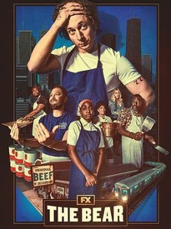
Harriet. From her escape from slavery through the dangerous missions she led to liberate hundreds of slaves through the Underground Railroad, the story of heroic abolitionist Harriet Tubman is told. | 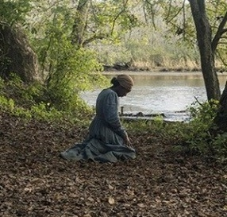
Coco (family friendly). Despite his family's generations-old ban on music, young Miguel dreams of becoming a musician like his idol Ernesto de la Cruz. Desperate to prove his talent, Miguel finds himself in the stunning and colorful Land of the Dead. After meeting a charming trickster named Héctor, the two new friends embark on an extraordinary journey to unlock the real story behind Miguel's family history. | 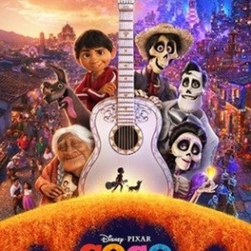
Movies and TV on the potential inheritance of A.I.
Ex Machina. A programmer at a huge Internet company, wins a contest that enables him to spend a week at the private estate of his firm's brilliant CEO. When he arrives, the programmer learns that he has been chosen to be the human component in a Turing test to determine the capabilities and consciousness of a beautiful robot. It soon becomes evident that the robot is far more self-aware and deceptive than either man imagined. | 
Three Black Mirror Episodes on A.I. Featuring stand-alone dramas -- sharp, suspenseful, satirical tales that explore techno-paranoia -- "Black Mirror" is a contemporary reworking of "The Twilight Zone" with stories that tap into the collective unease about the modern world. | 
Her. A sensitive and soulful man earns a living by writing personal letters for other people. Left heartbroken after his marriage ends, Theodore becomes fascinated with a new operating system which reportedly develops into an intuitive and unique entity in its own right. He starts the program and meets "Samantha", whose bright voice reveals a sensitive, playful personality. "Friend" relationship soon deepens into love. | 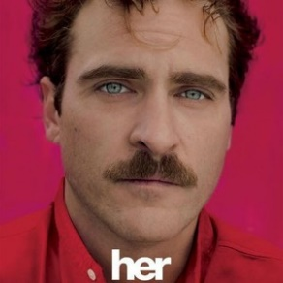

Movie descriptions were extracted from Rottentomatoes.com. All images were downloaded from Rottentomatoes.com.

Reflection Questions

Don’t treat these questions like “homework” or try to answer everyone. Instead, make time to meditate on the list and then pick the one question that speaks to you most. The goal is to figure out which question captures the call of your inner voice? Which one contains “your work”? And what is that question trying to get you to notice or acknowledge?

Often it helps to read the list to a friend or loved one and ask them which question they think is the question you need to wrestle with!

- What metaphor best describes your relationship to your family heritage? A giant hug? A dinner table with everyone talking at once? An anchor? A guidepost?
- What story told by (or about) your ancestors has shaped you the most?
- How has staying close to your ancestors been healing for you?
- If you could talk to one of your ancestors, who would you choose? And what would you ask them?
- What is your favorite family memento? And why does it have such a hold on you?
- If you could change one thing about your family heritage, what would it be?
- Often parents consciously or unconsciously transfer their unfilled dreams onto their children. What have you learned about dancing with your parents’ unfulfilled dreams?
- How have your ancestors helped you understand and hold on to beauty?
- What story do you want to be remembered by?
- What article of clothing ties you to your ancestors?
- We usually think of heritage as tied to people, but places shape us as much as our family trees. What “inheritance” was passed on to you by your childhood hometown or childhood house?
- What’s the legacy of your first embarrassment?
- What’s the legacy of your first award/triumph?
- It’s been said that we are remembered for the rules we break. What broken rule might you be remembered by? What rule did your parents break?

What’s your question? Your question may not be listed above. As always, if the above questions don't include what life is asking from you, spend the month listening to your days to find it.

Meditations, Prayers, & Blessings
[An asterisk (*) marks permissioned for online use.]

Remember the Sky
Joy Harjo
Full poem found at https://www.poets.org/poetsorg/poem/remember-0

Remember your birth, how your mother struggled
to give you form and breath. You are evidence of
her life, and her mother’s, and hers...
Remember the earth whose skin you are...
Remember you are all people and all people are you…

It Is That Time and That Place*
Rev. Qiyamah Rahman
Full piece at https://www.uua.org/worship/words/poetry/it-time-and-place
Permission Source

Now is the time to call on the memories of the ancestors who thought they could not walk another step toward freedom—and yet they did…
Time to make them proud and show them, and ourselves, what we are made of…
Did you not know that we would have to change places?...
It is that time and that place to know that it is our turn, that we must leave a legacy for our children. And all the children…
We are the ones we’ve been waiting for!
For that, let us be eternally grateful…

They Are with Us Still *
Kathleen McTigue
Full piece at https://www.uua.org/worship/words/affirmation/they-are-us-still
Permission Source

Those who lived before us,
who struggled for justice and suffered injustice before us,
have not melted into the dust,
and have not disappeared.

They are with us still.
The lives they lived hold us steady...

Prayer of Remembrance *
Rev. Lori Walke
Full prayer found at https://www.uua.org/worship/words/prayer/prayer-remembrance
Permission Source

That’s the thing about people who are loved: their memories keep. They’re never too far away. They come to us in a song lyric or a line of movie dialogue or on a long walk. What was it that they always said? Oh, that’s right. And they always had to have it a certain way. So maybe we’ll do it that way, and laugh a little, in memoriam. Be with us, Holy One, as we grieve over the empty chairs at the table…

Breaths
Birago Diop
Full poem and background information found at http://pancocojams.blogspot.com/2015/01/birago-diop-breaths-poem-sweet-honey.html

“...The dead are not gone forever.
They are in the paling shadows...
The dead are not beneath the ground,
They are in the rustling tree..
They are in a woman's breast,
A child's crying, a glowing ember…”

These are lyrics to the well-loved song by Sweet Honey In The Rock: https://www.youtube.com/watch?v=o3e-zLKyZLw&t=44s. Consider following a prayerful reading of the text with the sung version of it.

Heritage Us *
Rev. David Breeden
Permission secured by Soul Matters

One:
It is not the date
you passed over
the water or land
to reach here. You
or kin long gone.

Many:
It is not the time,
or the way you
arrived that makes
a citizen, a neighbor.

One:
In the rich weave of a nation,
ancestors will dance in the fabric,
the songs they sang echoing on.

Many:
From the wisdom and folly of elders,
traditions persist, for good and ill,
a shared story when told in truths . . .

One:
the truth that we are woven
together, aware through traditions,
the whispers in ancient oaks,
the laughter of the young together.

Many:
Our heritage calls,
echoing voices,
urging love,
summoning joy.

One:
In all our veins flows
the one blood of history.
Promises broken,
injustices done.

Many:
Forgive the past,
as best we can know it,
the true and real—
the real--a heartbeat,
a sob, love, longing,
a vision beyond time’s horizon,
roots deep,
branches reaching.

One:
Treasure the heritage,
for heritage is a treasure,
binding us together,
united in the quest
to free each other

Stories For All Ages

Picture Books
Be A Tree by Maria Gianferrari (Author), Felicita Sala (Illustrator)

Our theme this month is The Gift of Heritage, of “Roots,” and this story explores the theme through sharing how people are like trees, with roots and sapwood. Our roots give us the gift of courage and wisdom when times get hard. We live in community just like a forest, and celebrate the diversity of roots, of heritages.

Book: https://www.amazon.com/Be-Tree-Maria-Gianferrari/dp/1419744224/
Read-Aloud: https://www.youtube.com/watch?v=-yg0VGfL_20

Powwow Day by Traci Sorell (Author), Madelyn Goodnight (Illustrator)

Our theme this month is The Gift of Heritage. This story explores the theme through the lens of the specific heritages, or roots, of Indigenous Peoples. The U.S. used to celebrate only Columbus Day in October but now we are reclaiming more and more truth about our roots and celebrating Indigenous People’s Day. The untrue stories that used to be told made the stories of Indigenous Peoples invisible. The gift of reclaiming our roots is to make the invisible, visible and to help enable the gift of healing. Just as the little girl in this story is healed by being connected to her community and to her roots, we all can receive healing by reclaiming truth in our roots.

Book: https://www.amazon.com/Powwow-Day-Traci-Sorell/dp/158089948X/
Read-Aloud: https://www.youtube.com/watch?v=ysKVgZduftk

The Tear Thief by Carol Ann Duffy (Author), Nicoletta Ceccoli (Illustrator)

Our theme this month is The Gift of Heritage. This story explores the theme through the lens of the gifts of LGBTQ+ roots/history. Carol Ann Duffy is a member of the LGBTQ+ community who wrote poems and also several children’s books. If she hadn’t been accepted when she came out as the first lesbian Poet Laureate, she might not have published her poems and books. And we would never have had the chance to be inspired by them! This story of The Tear Thief is one she made up. Notice how creative she is and how her poetry slips into her descriptions of tears and the tear thief.

Book: https://www.amazon.com/Tear-Thief-Carol-Ann-Duffy/dp/1846866227
Read-Aloud: https://www.youtube.com/watch?v=wE2zoIVOq08&t=122s

Born With a Bang; The universe tells the cosmic story by Jennifer Morgan

Our theme this month is The Gift of Heritage. This story explores the theme through the lens of the gifts of science and reason. When we take the time to learn about the roots of the universe, and how we are physically part of everything around us, a sense of connection forms and hopefully results in a desire to do good for the world around us and everyone in it. This story tells of the creation of the universe which science has figured out as best as all the theories can tell.”

Book: https://www.amazon.com/Born-Bang-Universe-Tells-Cosmic/dp/1584690321
Read-Aloud: https://www.youtube.com/watch?v=vbnd3aW0Pdg

Badger’s Parting Gifts by Susan Varley.
For use in remembrance services
Book: https://www.amazon.com/Badgers-Parting-Gifts-Susan-Varley/dp/0688026990/
Read-Aloud: https://www.youtube.com/watch?v=tRTRABhJTbo

Tellable Tales

The Little Oak Tree by (told in Unitarian Universalist Sunday School)
At the edge of the forest stood a large fat mushroom.
Next to it, there grew a spindly plant about the same height, with four leaves.
One day, the mushroom said to its companion, “Say there, Skinny, I’ve been watching you.
How come when anyone pushes over a mushroom, we go all to pieces but when you get pushed over you can straighten up again as good as new?”
The little plant thought for a while, then it answered, “I guess it’s because I have something down under the ground called roots.
They go down deep and when I get pushed, I just hang on tight with my roots until I’m all right again.”
“Hey, that’s a neat idea,” said the mushroom, “How do you go about getting these roots?”
“Well,” said its friend slowly, “It takes a long time. I’ve been growing mine for almost a year.”
“A year!” shouted the mushroom,
“Who’s got that kind of time??
A whole year growing something that you can’t even see!
They may be handy, but that’s the silliest waste of time I ever heard!”
And the mushroom laughed and laughed.
Finally, it said to his forest friend, “By the way, Skinny, when you’ve got all your fancy roots grown, what do you expect to be?”
The little plant seemed to grow taller as it said, “Do you see that tallest oak standing strong against the winds on the hill?
That’s my mother, and someday I’m going to be strong and tall just like her.”

Haudenosaunee Creation Myth
This story used to be described as an Iroquois Myth. The people are starting to reclaim their roots and call themselves by their own name, Haudenosaunee.
https://nytraditions.org/digital-heritage/skywoman-creation-story or a longer version https://www.oneidaindiannation.com/the-haudenosaunee-creation-story/

The Story of Being Trans
Interviews with Violet, age 13, Zach, age 9, and Aya, Age 9, sharing their experiences of being trans.
https://cupofjo.com/2021/06/14/transgender-kids-boys-girls/

Writing to Dr. Albert Einstein
This is a story of how Unitarian children wondering about the universe and God wrote a letter to Albert Einstein, world-famous scientist. His answers were filled with wonder and curiosity about the universe.
http://uuaimg-archive.s3.amazonaws.com/mfc/Fahs_Todays_Children.pdf
Pg. 167 “Do Scientists Pray?” to pg. 171. End with “One said he could sometimes pray in
church, but the others spoke of finding the experience of prayer most often when feeling in the
presence of the mystery or wonder of the natural world.”

The Parable of the Mustard Seed
A Wisdom Tale from the Buddha, on grieving the loss of those who have gone before.
For use in remembrance services
https://www.turningwheel.org.uk/buddhist_stories/kisa-gotami-and-the-mustard-seed/

