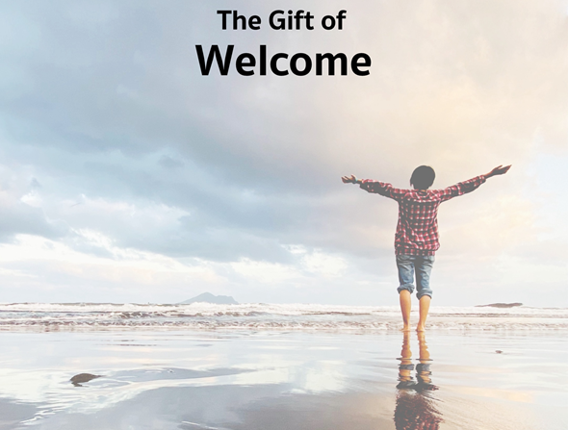

Come one, come all!
Come with your missing pieces and your extra screws
Come with your hard edges and your soft spots
Come with your bowed heads and upright spines.
--Rev. Ian W. Riddell

Monthly Theme Resources  Sepember 2023 | 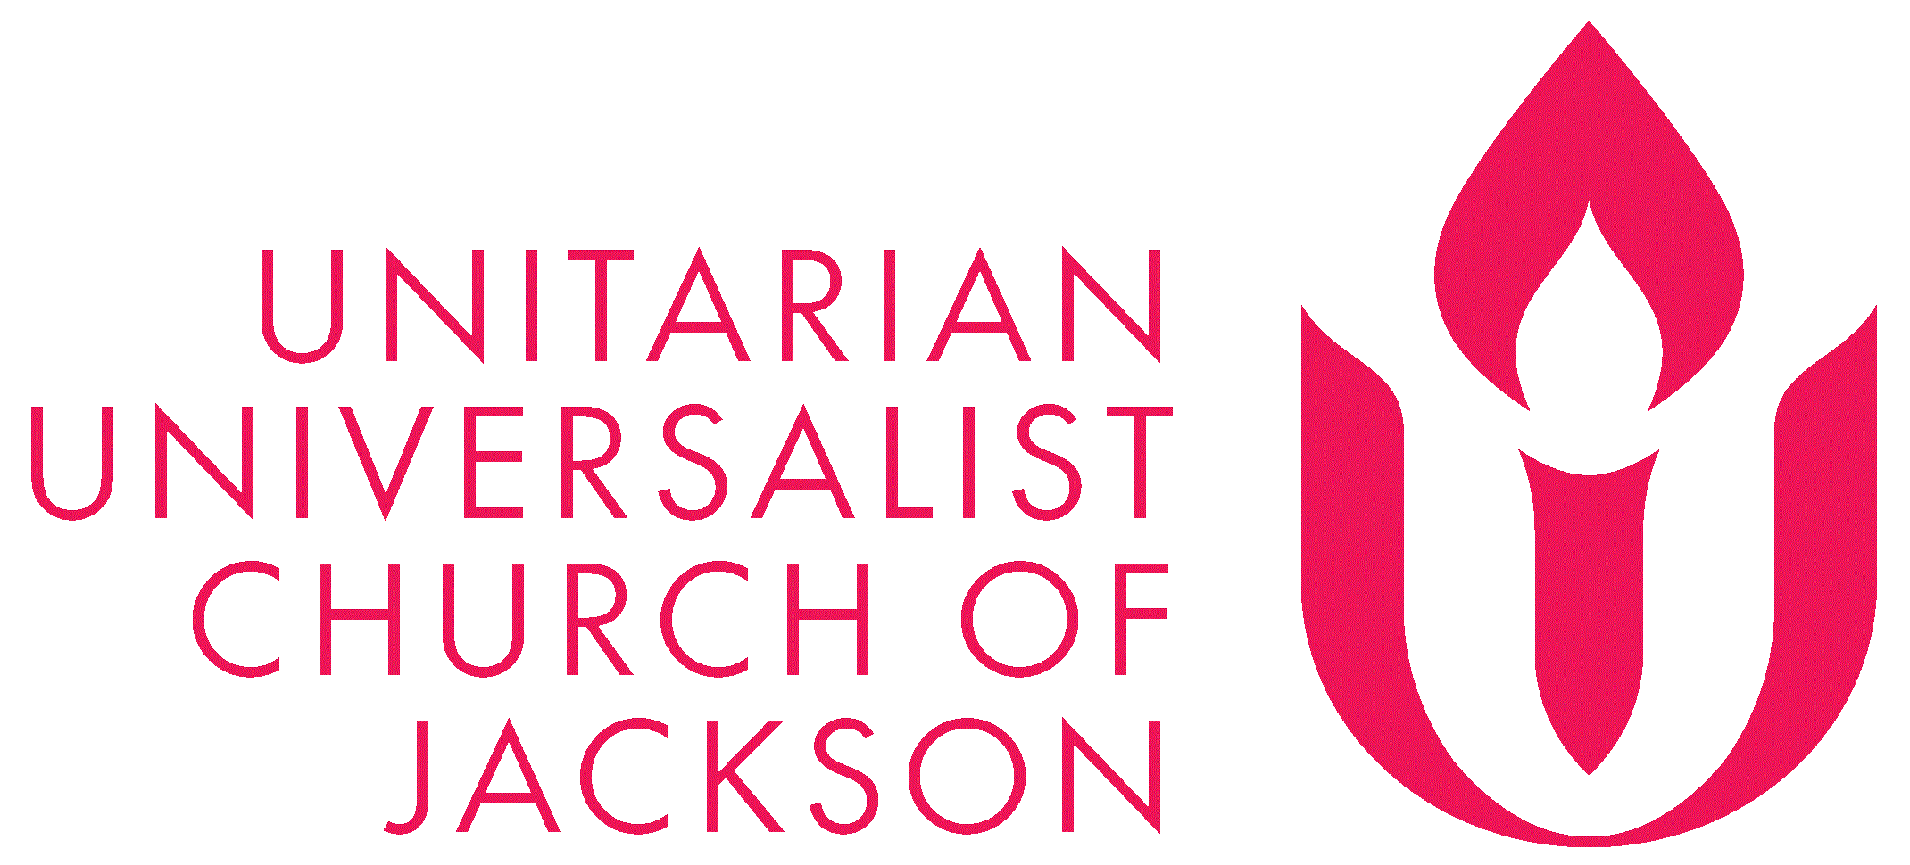

Calendar Connections: September 2023
Month | Suicide Prevention Month
Early Sept | Ingathering/Water Communion Ritual - Early September UU Ritual
Sept 4 | Labor Day (*first Monday)
Sept 8 | International Literacy Day
Sept 10 | World Suicide Prevention Day
Sept 11 | 9-11 Remembrance
Sept 15 – Oct 15 | Hispanic Heritage Month
Sept 15 – Sept 17 | Rosh Hashanah - Jewish New Year - Evening of Fri, Sep 15, 2023 to the Evening of Sun, Sep 17, 2023
Sept 19 | The first meeting of the Transcendentalist Club - (1836), more here and here
Sept 19 | Talk Like a Pirate Day
Sept 21 | Mabon/Autumn Equinox – Wicca, more here
Sept 21 | International Peace Day, more here
Sept 21 | World Gratitude Day
Sept 22 | Hobbit Day
Sept 23 | Bisexual Pride Day, CBD, Bisexual Pride, and Bi Visibility Day
Sept 23 | Bisexual Awareness Week - Week of September 23, more here
Sept 24-25 | Yom Kippur - Jewish Day of Atonement
Sept 26 | Mawlid al-Nabi - the birthday of the Prophet Muhammad
Sept 26 | Johnny Appleseed Day
Sept 30 | Rumi’s birthday - (1207)
Sept 30 | Universalism Day: John Murray preaches 1st sermon in US (1770), more here

Recommended Resources for Personal Exploration & Reflection

Word Roots & Definitions

Welcome dates back to Anglo-Saxon days, from Beowulf. The word was originally wilcuma in Old English, a combination of wil (pleasure) plus cuma (guest). The verb form, wilcumian, meant to receive someone or something with pleasure.

Wise Words

It’s amazing really. As a human being all you have to do is enumerate exactly the way you don’t feel at home in the world, and the moment you’ve uttered the exact dimensionality of your exile, you are already on your way home.
David Whyte

We belong to every part of our lives and every part of our lives belongs to us. Even the failures. The cruelty. The betrayals. The addictions. The cowardice. Until we embrace and welcome back those scared and tender parts with the kindness and forgiveness we so generously give to others, we will never be whole. We will never be home.
Rev. Scott Tayler

I believe every inch of America is sacred, from sea to shining sea. I believe we make it holy by who we welcome and by how we relate to each other. Call it my Muslim eyes on the American project. “We made you different nations and tribes that you may come to know one another,” says the Qur’an.
Eboo Patel

America needs to reconcile with itself and do the work of apology: To say to indigenous, black, and brown people, we take full ownership for what we did. To say, we owe you everything. To say, we see how harm runs through generations. To say, we own this legacy and will not harm you again. To promise this non-repetition of harm would require nothing less than transitioning the nation as a whole. It would mean retiring the old narrative about who we are—a city on a hill—and embracing a new narrative of an America longing to be born, a nation whose promise lies in the future, a nation we can only realize by doing the labor: reckoning with the past, reconciling with ourselves, restructuring our institutions, and letting those who have been most harmed be the ones to lead us through the transition.
Valarie Kaur, on our society welcoming in the work of apology

Do not neglect to show hospitality to strangers, for thereby some have entertained angels unawares.
Hebrews 13.1 - Christianity

Hospitality is a form of worship.
Babylonian Talmud

Hospitality is simply love on the loose.
Joan D. Chittister

[Hospitality] is the first step toward dismantling the barriers of the world. Hospitality is the way we turn a prejudiced world around one heart at a time.
Joan D Chittister

If you go without belonging for long enough, if you’ve known the sting of betrayal, you can end up manufacturing an identity from your alienation. To protect yourself from the risk of exclusion, you begin initiating distance on your own by calling yourself ‘loner’ or ‘independent.’ But a life lived with trust only in the self is exhausting.
Cole Arthur Riley

A real conversation always contains an invitation. You are inviting another person to reveal herself or himself to you, to tell you who they are or what they want… A year or so ago, I found myself in exactly this dynamic, my daughter's bedroom door slammed shut just as I was about to say a last, deeply satisfying unhelpful thing. But I caught myself… I gave it the old 10-minute cooldown time, made tea and a plate of cookies… Then I knocked on her door and said in a very different, more invitational voice, "Come on, Charlotte, I've made tea. Let's go and have a talk." As soon as I put the tray down and we sat next to each other, almost by accident I happened to say exactly the right thing—I said, "Charlotte, tell me one thing you'd like me to stop doing as a father. And tell me one thing you'd like me to do more of." She suddenly gazed up at me with a lovely look in her eyes, one I knew from her very early infancy. She was engaged again because at last I was really inviting her to tell me who she had become—not who she had been or who I wanted her to be—but who she was now.
David Whyte

I was beginning to learn that home is the space within us and between us where we feel safe—and brave. It is not a physical space as much as it is a field of being.
Valarie Kaur

Jung once said he began calling God all those "things which cross my willful path violently and recklessly, all things which upset my subjective views, plans and intentions, and change the course of my life for better or for worse." The divine is that power which disrupts everything. What if our practice were to court a similar holy disruption? To welcome in everything which challenges my perspective on how the world works, which upsets all the plans I have for myself, and turns them on their heads?
Christine Valters Paintner

This is going to sound crazy. Say yes to everything. Accept [and welcome in] all offers. Go along with the plan. Support someone else's dream. Say: yes”; “right”; “sure”; “I will”; “okay”; “of course”; “YES!” ... When the answer to all questions is yes, you enter a new world, a world of action, possibility, and adventure.
Patricia Ryan Madson
Poetry

He drew a circle that shut me out--
Heretic, a rebel, a thing to flout.
But Love and I had the wit to win:
We drew a circle that took him in!
Edwin Markham

Ah, Grief, I should not treat you
like a homeless dog
who comes to the back door…
I should trust you.
I should coax you
into the house and give you
your own corner…
Denise Levertov

The Arabs used to say,
When a stranger appears at your door,
feed him for three days
before asking who he is,
where he’s come from,
where he’s headed.
That way, he’ll have strength
enough to answer.
Or, by then you’ll be
such good friends
you don’t care…
Naomi Shihab Nye
On welcoming change

Articles

Welcome to the Brink of Everything, Parker J. Palmer
https://onbeing.org/blog/parker-palmer-welcome-to-the-brink-of-everything/

On welcoming the gifts of age.
Excerpt: “Age brings diminishments, but more than a few come with benefits. I’ve lost the capacity for multitasking, but I’ve rediscovered the joy of doing one thing at a time. My thinking has slowed a bit, but experience has made it deeper and richer. I’m done with big and complex projects, but more aware of the loveliness of simple things…”

On the Article II Study Commission’s Invitation to Welcome New Values
Introduction and context: https://www.questformeaning.org/quest-article/embracing-the-living-tradition/
The proposal: https://www.uua.org/files/2023-06/Article%202%20Package.pdf

Books

Britt-Marie Was Here
Fredrik Backman
In the Shelter: Finding a Home in the World
Padraig O Tuama
Related talk HERE

Four Books on Welcoming in Grief
https://www.bookpage.com/features/gentle-guides-to-healing-from-grief/

Trusting Change: Finding Our Way Through Personal and Global Transformation
Karen Hering

Videos & Podcasts

What Makes You Feel “Welcomed Home”?
https://www.youtube.com/watch?v=rWt76WqRCVs

Love Reaches Out
https://www.youtube.com/watch?v=OvlPa28cVfA
A visual and musical meditation asking us, “How is love calling you to reach out and welcome others in?

Lost Together
https://www.youtube.com/watch?v=8HNFqeZI-J4
A meditation on the path of welcoming in all the different parts of ourselves

Departing the Quiet with Cole Arthur Riley
https://www.youtube.com/watch?v=ibvaV5apMmA
On finding and offering welcome through the words of blessing & prayer.

The Black Thought Project
https://www.youtube.com/watch?v=7Bj7GpwA0Vw
On welcoming and centering Blackness
Related podcast

Welcoming Stories
http://www.firstpersonamerican.org/stories_welcoming.html
A video series encouraging Americans to become more welcoming by inviting immigrants to share their story about someone who made a big difference in their lives when they first arrived.

Getting Called Out: How to Apologize
https://www.youtube.com/watch?v=C8xJXKYL8pU
On welcoming the work of accountability and apology.

The Urgent Need for Compassion
https://www.youtube.com/watch?v=Tq3C9R8HNUQ
Interview with Alok Vaid-Menon on how the gender binary separates us all from a welcoming world.

Our House is So Big, Lisa Kron
https://www.youtube.com/watch?v=AejUt7TdexI

Music

Two different playlists for each of our monthly themes: one in Spotify and another in YouTube. They are organized as a journey of sorts, so consider listening from beginning to end and using the playlists as musical meditations.

Click for the Spotify playlist on Welcome.
Click for all Spotify playlists.
Click for the YouTube playlist on Welcome.
Click for all the YouTube playlists.

Movies & TV

Marcel The Shell With Shoes On. Marcel, a 1-inch-tall shell, lives with his grandmother, Connie, the only residents of their town after their neighbors' sudden, mysterious disappearance. When discovered by a guest amongst the clutter of his Airbnb, the short film he posts online brings Marcel millions of passionate fans and a new hope of reuniting with his long-lost family. [Google] | 
The Last Black Man in San Francisco. Jimmie and his best friend Mont try to reclaim the house built by Jimmie's grandfather, launching them on a poignant odyssey that connects them to their past, even as it tests their friendship and sense of belonging in the place they call home. | 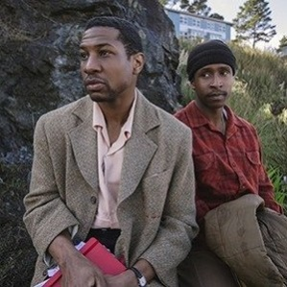
Antonia’s Line. After World War II, Antonia (Willeke van Ammelrooy) and her daughter, Danielle (Els Dottermans), go back to their Dutch hometown, where Antonia's late mother has bestowed a small farm upon her. There, Antonia settles down and joins a tightly-knit but unusual community. Those around her include quirky friend Crooked Finger (Mil Seghers), would-be suitor Bas (Jan Decleir) and, eventually for Antonia, a granddaughter and great-granddaughter who help create a strong family of empowered women. | 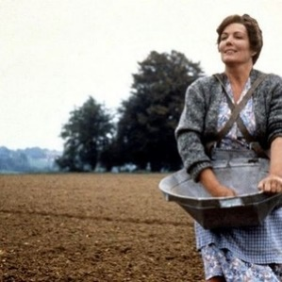
Taylor Mac's 24-Decade History of Popular Music. In 2016, Taylor Mac performed a one-time-only, 24-hour immersive theatrical experience in front of a live audience at St. Ann's Warehouse in Brooklyn. The concert offered an alternative take on U.S. history, narrated through music that was popular from the nation's founding to the present, with Mac transforming hourly by changing into elaborate, decade-specific costumes by Mac's longtime collaborator Machine Dazzle. In the show, Mac and 24 musicians interpret 24 songs, from "Yankee Doodle" to "Gimme Shelter," "Born to Run," and "Gloria". | 
Lost in Translation. A lonely, aging movie star named Bob Harris (Bill Murray) and a conflicted newlywed, Charlotte (Scarlett Johansson), meet in Tokyo. Bob is there to film a Japanese whiskey commercial; Charlotte is accompanying her celebrity-photographer husband. Strangers in a foreign land, the two find escape, distraction and understanding amidst the bright Tokyo lights after a chance meeting in the quiet lull of the hotel bar. They form a bond that is as unlikely as it is heartfelt and meaningful. | 
Here and Away (short film). Here and Away is a life in the day of a young boy living in the countryside. He experiences the world go by, leaving him with unanswered questions, rather than any resolve. The film is intentionally shot very simply and without a linear dramatic narrative. Rather, it evokes feelings of wonder and questioning, and captures passing moods and moments of becoming.

Movie descriptions were extracted from Rottentomatoes.com, except the description of Here and Away was from imdb.com. All images were downloaded from Rottentomatoes.com.

fd
d

Reflection Questions

Don’t treat these questions like “homework” or try to answer everyone. Instead, make time to meditate on the list and then pick the one question that speaks to you most. The goal is to figure out which question captures the call of your inner voice? Which one contains “your work”? And what is that question trying to get you to notice or acknowledge?

Often it helps to read the list to a friend or loved one and ask them which question they think is the question you need to wrestle with!

- Who welcomed you in when you needed it most? How has that gift changed you? What would you say to the person if you had the chance?
- What do you know now about welcoming in the present moment that you didn’t know when you were younger?
- What if, as some say, God is the force that disrupts our comfortable plans and notions? What if wholeness and holiness only leak into our lives when we welcome those moments of life being turned on its head?
- What would you tell someone younger than yourself about welcoming in grief?
- Have you ever welcomed in a moment so fully that you suddenly felt one with it?
- What part of you do you wish your family of origin would have welcomed more enthusiastically?
- Is welcoming in an awareness of death helpful?
- Do you know what it’s like to encounter a welcome that requires you to remove parts of yourself to belong?
- Theologian Joan D. Chittister said, “Hospitality is simply love on the loose.” Does that ring true for you?
- Has welcoming change gotten easier or harder as you’ve grown older?
- What part of yourself is hardest to welcome in and embrace with compassion: Your vulnerable self? Your flawed self? Your easily frightened self? Your angry self?
- Has welcoming the forgiveness of others gotten easier or harder as you’ve gotten older?
- We all have past friendships we wish we could have taken deeper, that were cut short because we moved or other life events took priority. If you could welcome one of those unfulfilled friendships back into your life, which one would it be? And why?
- What is trying to get itself welcomed into your life right now?
- What new ideas have you welcomed in since you’ve been a UU?
- If you were asked to name 2 ways you could help make your church more welcoming, what would they be?

What’s your question? Your question may not be listed above. As always, if the above questions don't include what life is asking from you, spend the month listening to your days to find it.

Meditations, Prayers, & Blessings
[An asterisk (*) marks permissioned for online use.]

Know You are Not Alone and Discover the Way Our Voices Rise, Rev. Gretchen Haley *
Soul Matters secured

For this one moment
Know only that you are loved
That you are safe, and whole and loved
Know that you belong here
Here among us, here upon this earth
In your body
However tired, or broken
Your heart may be
Whatever fear, disappointment, anger
you carry
For this hour know you are not alone
Feel the presence of others
Surrounding you,
Breathing beside you, and with you,
Discovering together the way our voices rise, and fall together
In harmony, in hope
Claim here a resilient freedom
The choice for love, for light, to live with joy
and gratitude and praise
as a form of resistance

Saved, Rev. Theresa Novak
Found HERE and in With or Without Candlelight, UUA meditation manual & Soul Matters “Common Shelf” Book

Rest awhile…
When you feel stronger,
just a bit,
notice those who need you too…

A Prayer Against Circles (On a wider welcome), Rev. Scott Tayler *
Full piece at https://docs.google.com/document/d/13ju1o3pH3BJJWUbOpx_MK5zgNDFI0m_U-7Y0BkBiWng/edit?usp=sharing
Soul Matters secured

let’s widen the circle until it breaks!
For as long as the circle exists
pieces and parts of ourselves
will always lie on the other side of the line.
The circle will never allow
the welcome we wish for…

There's My Temple, Ma Theresa "Tet" Gustilo Gallardo *
Full piece at www.uua.org/worship/words/affirmation/theres-my-temple
Permission Source

There's my temple!
Believer, unbeliever or wild one…
Nature-tripper, urban-dweller, or saint…
History-maker, marginalized, unorganized.
You are welcome!

In Sweet Company, Margaret Wolff
Full poem here and here

We sit together and I tell you things,
Silent, unborn, naked things
That only my God has heard me say.
You do not cluck your tongue at me
Or roll your eyes...
You stay with me in the dark…
You make room in your heart for my voice...
I see my future Self in you…
In sweet company
I am home at last.

The Power Is Here Now, Alexia Chellun (Musical Meditation)
www.youtube.com/watch?v=7rJfU1A6cxs

Love Reaches Out
(Musical Meditation)
A visual and musical meditation asking us, “How is love calling you to reach out and welcome others in?
www.youtube.com/watch?v=OvlPa28cVfA

The Road Home, Stephen Paulus

(Video Meditation)
www.youtube.com/watch?v=LbwhSP3ZIq4&list=RDAarowtnr-hs&index=10

Welcoming Water Communion, Rev. Allison Palm (For Water Communion)
Full piece at https://docs.google.com/document/d/1Dek6ia4iQjInvO7NPO-olsfEGtaTlaNzYWnz_jH69Ko/edit?usp=sharing

“As you contribute your water, you are welcomed into this community.
And I also invite you to consider: how will you be welcoming this year?
Will you welcome with an open mind? ...a loving heart? …helping hands?”

River Call, Rev. Manish Mishra-Marzetti

(For Water Communion)
Found in Voices from the Margins, UUA meditation manual & Soul Matters “Common Shelf” Book

We find ourselves here,
in community.
Each called
from many different
journeys…
onto this river road…

Stories For All Ages

Picture Books

The Big Umbrella
by Amy June Bates, co-written with Juniper Bates
In this story, an umbrella makes room for everyone, no matter how tall, how hairy, or how many legs.
Book: https://www.amazon.com/Big-Umbrella-Amy-June-Bates/dp/1534406581
Video: https://www.youtube.com/watch?v=d7JZ9rRIZ3w

The Water Princess
by Susan Verde and illustrated by Peter H. Reynolds
Book: The Water Princess
The Water Princess Read-Aloud: https://www.youtube.com/watch?v=tIWAjQhClK0
Our theme this month is The Gift of Welcome. This story explores the theme through the lens of being open to the many sources of nourishment. This story is about a little girl named Princess Gie Gie. Princess Gie Gie lives in a beautiful land, but water is very scarce. Every morning Gie Gie walks miles with her mother to collect water, and she dreams of a life and a time when her village will have access to nourishing, clean drinking water.

Everybody’s Welcome
by Patrica Hegarty and illustrated by Greg Abbott
Book: Everybody’s Welcome
Read-Aloud: https://www.youtube.com/watch?v=RJFC3dPXqyw
Our theme this month is The Gift of Welcome. This story explores the theme through the lens of being open to the calls of our faith. One of those calls is to be willing to do things that will make a difference and ensure that people truly feel welcome, even when it is a challenge.

By the Light of the Harvest Moon
by Harriet Ziefert
Book: By The Light of the Harvest Moon
Read-Aloud: https://www.youtube.com/watch?v=DYqLasEqBJA
Our theme this month is The Gift of Welcome. This story explores the theme through the lens of being open to balance and the Autumn Equinox. This story is about The Leaf People of Apple Hill Farm and how they celebrate the autumnal equinox.

The Hardest Word: A Yom Kippur Story"
by Jacqueline Jules
Book: https://www.amazon.com/Hardest-Word-Yom-Kippur-Story/dp/1580130283
Read-Aloud: https://www.youtube.com/watch?v=43Pk8_i-0sc
Our theme this month is The Gift of Welcome. This story explores the theme through the lens of welcoming apology and forgiveness into our lives and relationships. This is a Yom Kippur story. Yom Kippur is the Jewish holiday of atonement. It is one of the most special and holiest of holidays.

Tellable Tales

Petra
By Marianna Coppo
On welcoming our changing selves. https://www.youtube.com/watch?v=9Lwf_clh_Tk&t=1s

The Cracked Pot
Indian Folktale, https://www.sloww.co/cracked-pot/
Our theme this month is The Gift of Welcome. This tale explores the theme through the lens of being open to the many sources of nourishment. This tale has been around for a very long time and traces its roots back to India, It is a wonderful example of welcoming things just as they are and how nourishment comes from many sources and places.

Mice in Council
Aesop Fable, PDF: https://www.excellence-in-literature.com/the-mice-in-council-a-medieval-fable/
Our theme this month is The Gift of Welcome. This tale explores the theme through the lens of being open to the calls of our faith. One of those calls is to take action. It is not enough to say we are welcoming or have an idea of wanting to be welcoming. Our faith calls us to act. We must be willing to do things that will make a difference and ensure that people truly feel welcome, even when it is a challenge.”

The Story of an Eagle
PDF: https://timesofindia.indiatimes.com/readersblog/vishwabramana/story-of-an-eagle-23667/
One thing most people afraid of is CHANGE, especially when it's painful or uncomfortable. But we all go through changes to grow. Our theme this month is The Gift of Welcome. This tale explores the theme through the lens of welcoming in change.

A Pillow Full of Feathers
PDF: https://www.chabad.org/library/article_cdo/aid/812861/jewish/A-Pillow-Full-of-Feathers.htm
Our theme this month is The Gift of Welcome. This tale explores the theme through the lens of being open to apology and forgiveness. This is a Jewish Wisdom Tale about how harm can be caused and the importance of an apology.

