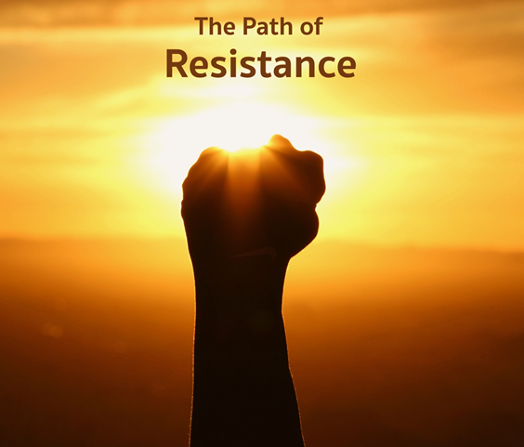

...it starts when you say We
and know who you mean, and each
day you mean one more.
--Marge Piercy, from The Low Road

Monthly Theme Resources April 2023 | 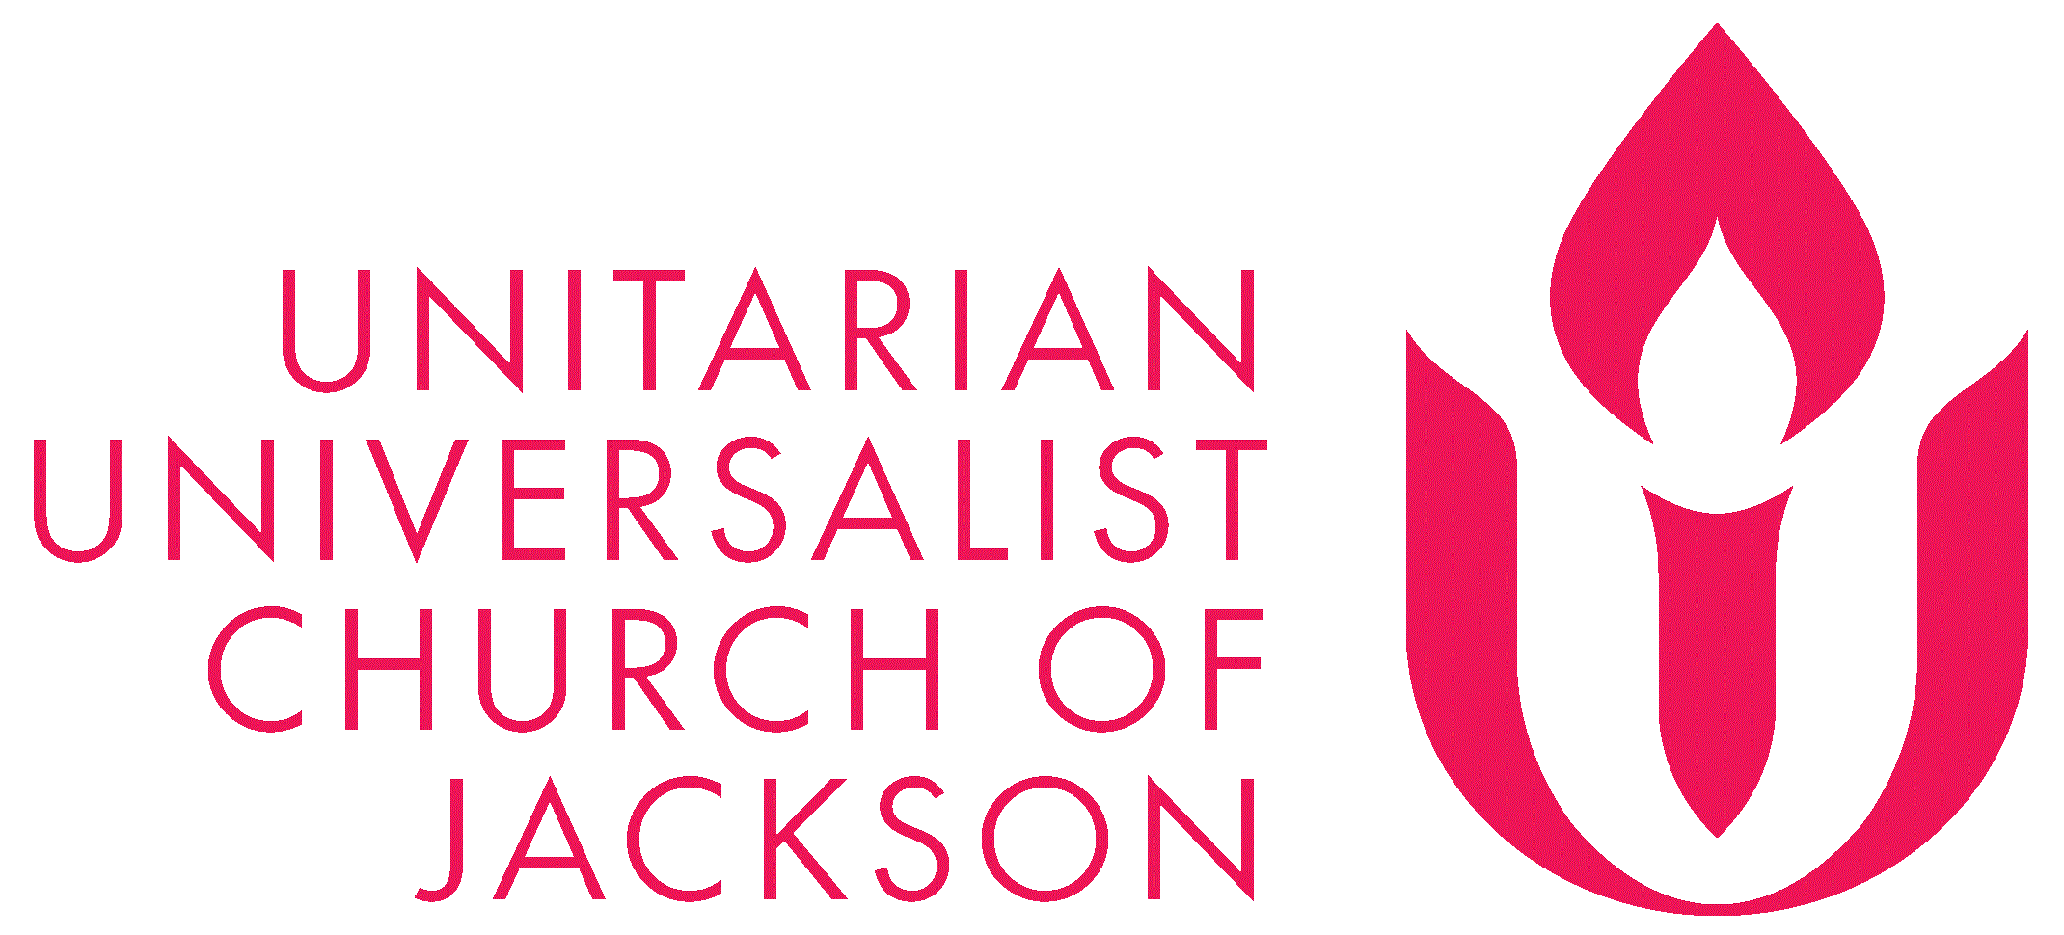

Calendar Connections: April 2023
Month | Arab American Heritage Month
Month | National Poetry Month (more here)
Feb. 22 – Apr. 26 | Lent (A humorous take)
Mar. 22 – Apr. 21 | Ramadan (more here and here)
Mar. 22 – Apr. 22 | Climate Justice Month
Apr. 1 | April Fool’s Day - (more here and here)
Apr. 3 | Martin Luther King Jr gives his “mountaintop speech” (1968)
Apr. 4 | Martin Luther King Jr Assassinated (1968)
Apr. 5 | Passover (Jewish, more here)  Star Trek Day (more here)
Apr. 7 | Good Friday - (Christian)  William Ellery Channing’s Birthday (1780)
Apr. 8 | Vesak - Celebration of Buddha's Birthday (Buddhist) - celebrated on April 8 in some countries and on various rotating dates in May by other countries. (more here, here, & here)
Apr. 9 | Easter (Christian)  Vimy Ridge Day (Canada)
Apr. 11 | Fair Housing Act passed (1968)
Apr. 12 | Freddie Gray is arrested in Baltimore and dies after sustaining injuries in police custody (2015)
Apr. 14 | Day of Silence (LGBTQ) - second Friday of April. (More here and here)  Death of Sophia Lyon Fahs (1978)
Apr. 17 | Yom HaShoah - begins at sunset
Apr. 21-22 | Eid al Fitr - end of Ramadan (Islam, more here)
Apr. 22 | Earth Day
Apr. 26 | Lesbian Visibility Day
Apr. 27 | National Tell a Story Day
Apr. 28 | National Superhero Day (more here)
Apr. 29 | First day of LA riots, sparked by acquittal of four white cops in the beating of Rodney King (1992)
Apr. 30 | Hosea Ballou’s Birthday (1771) (more here)

Recommended Resources for Personal Exploration & Reflection

Wise Words

Change is never painful. Only resistance to change is painful.
Author Unknown

What you resist, persists.
Carl Jung

Our lives begin to end the day we become silent about things that matter.
Martin Luther King, Jr.

After all, if you do not resist the apparently inevitable, you will never know how inevitable the inevitable was.
Terry Eagleton

Once a reporter asked A.J. Muste, “Do you really think you are going to change the policies of this country by standing out here alone at night in front of the White House with a candle?”
Muste replied softly: “Oh I don’t do this to change the country. I do this so the country won’t change me.”
Frederic and Mary Ann Brussat

The role of the artist is to make revolution irresistible.
Toni Cade Bambara

Resist the finished wash cycle and the dishes clamoring for clean-up. Ignore the pileup by the front door… [Instead make room for] the first quiet of the morning. It is thin and needy, hungry for your touch. You will miss it when it goes, siphoning out the way it does, toppled by the weight of all your noisy urgencies.
Maya Stein

When we acknowledge that we exist in an anti-black world that is set up to ensure we do not live, to choose life and to choose to enjoy any aspect of that life is a radical act.
Kleaver Cruz

Don’t just resist cynicism — fight it actively... Like all forms of destruction, cynicism is infinitely easier and lazier than construction. There is nothing more difficult yet more gratifying in our society than living with… faith in the human spirit… This [faith] remains the most potent antidote to cynicism. Today, especially, it is an act of courage and resistance.
Maria Popova

The only way to deal with an unfree world is to become so absolutely free that your very existence is an act of rebellion.
Albert Camus

Black joy matters. Black love matters. Black rest matters. They all matter. Why? Simply put: Our existence is resistance.
L'Oreal Thompson Payton

Rest is a form of resistance because it disrupts and pushes back against capitalism and white supremacy. Both of these toxic systems refuse to see the inherent divinity of human beings and have used human bodies as a tool for production, evil and violence for centuries. Grind culture has made us into human machines, willing and ready to donate our lives to a capitalist system that thrives by placing profit over people.
Tricia Hersey

Caring for myself is not self-indulgence, it is self-preservation, and that is an act of political warfare.
Audre Lorde

Your uprising against the forces of darkness has got to do more than say "no." A fierce, primal yes should be at the heart of your crusade.
rob brezny

This will be our reply to violence: to make music more intensely, more beautifully, more devotedly than ever before.
Leonard Bernstein

So the question is not whether we will be extremists, but what kind of extremists we will be. Will we be extremists for hate or for love? Will we be extremists for the preservation of injustice or for the extension of justice?
Martin Luther King, Jr.

Poetry

You may write me down in history
With your bitter, twisted lies,
You may trod me in the very dirt
But still, like dust, I'll rise.

Does my sassiness upset you?
Why are you beset with gloom?...
Did you want to see me broken?
Bowed head and lowered eyes?...
Maya Angelou

Be soft.
Do not let the world
make you hard.
Do not let pain
make you hate.
Do not let bitterness
Steal your sweetness.
Kurt Vonnegut

So, friends, every day do something
that won’t compute… Work for nothing.
Take all that you have and be poor.
Love someone who does not deserve it.
Denounce the government and embrace
the flag….
Ask the questions that have no answers…
Laugh.
Laughter is immeasurable. Be joyful
though you have considered all the facts…
Wendell Berry

Books

Pleasure Activism: The Politics of Feeling Good
adrienne maree brown

Octavia's Brood: Science Fiction Stories from Social Justice Movements

How to Do Nothing: Resisting the Attention Economy
Jenny Odell

Rest is Resistance: A Manifesto
Tricia Hersey

Videos & Podcasts

This Is Not A Humanising Poem
Suhaiymah Manzoor-Khan
https://www.youtube.com/watch?v=G9Sz2BQdMF8&t=127s

The Secret
https://www.youtube.com/watch?v=BwsuiWM2GQo
On resisting by surrendering

Meet the Resistance Revival Chorus
https://www.youtube.com/watch?v=asT51-ZM_yY
The chorus in action: https://www.youtube.com/watch?v=Bu1K4kU6hdk&t=48s

A Letter To Remind Myself Who I Am
Shane Koyczan
https://www.youtube.com/watch?v=IXpG1DNSsBM&t=98s
On resisting the lure to quit

Open-Hearted Beauty
Ahlaam Lala Abduljalil
https://www.youtube.com/watch?v=UgwzHkkPZbw
On the resistance required to choose your beauty

Bodies of Resistance
Sonya Renee Taylor
https://www.youtube.com/watch?v=wR5ISTTlmtA

Got Climate Doom? Here’s What You Can Do to Actually Make a Difference
https://podcasts.apple.com/us/podcast/the-argument/id1438024613?i=1000541325100
Focusing our climate catastrophe resistance on individual behavior is a good start, but it won’t bring the change that is needed; only large-scale political action and resistance will save us!

How Occupy Wall Street Reshaped Politics, Kicked Off New Era of Protest
https://www.youtube.com/watch?v=A9X6HDU4NiI

The Success of Nonviolent Civil Resistance, TED Talk
https://www.youtube.com/watch?v=YJSehRlU34w
“Then I analyzed the data, and the results blew me away. From 1900 to 2006, nonviolent campaigns worldwide were twice as likely to succeed outright as violent insurgencies.” Related podcast here

The Forger
https://www.youtube.com/watch?v=Dup6KOoaAUc&t=319s
As a teenager, Adolfo Kaminsky supported the resistance to the Nazi and saved thousands of lives by forging passports to help children flee.
Related article: https://www.thisiscolossal.com/2023/01/the-forger-adolfo-kaminsky/

Music
Two different playlists in Spotify and in YouTube are organized as a journey of sorts, so consider listening from beginning to end and using the playlists as musical meditations.

Spotify playlist on Resistance.
YouTube playlist on Resistance.

Contemporary Songs

- We Shall Overcome - Charles Tindley (Arr.)
- This Land is Your Land - Woody Guthrie
- I Will Survive - Gloria Gaynor
- I'm a Survivor - Beyonce
- A Change is Gonna Come - Sam Cooke
- Strange Fruit - Billie Holiday
- Get Up, Stand Up - Bob Marley & The Wailers
- Sunday, Bloody Sunday - U2
- The Times They Are A Changin' - Bob Dylan
- Fight Song - Rachel Platten
- Rise Up - Andra Day
- Killing in the Name Of - Rage Against the Machine
- Resistance - Muse

Movies & TV

Call Jane. Chicago, 1968. As the city and the nation are poised on the brink of political upheaval, suburban housewife Joy (Elizabeth Banks) leads an ordinary life with her husband and daughter. When Joy's pregnancy leads to a life-threatening heart condition, she must navigate an all-male medical establishment unwilling to terminate her pregnancy in order to save her life. | 
Crip Camp. A groundbreaking summer camp galvanizes teens who have disabilities. | 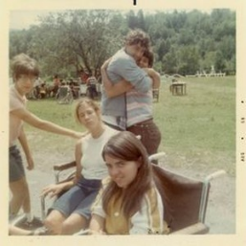
AWAKE, A Dream from Standing Rock. The Standing Rock Sioux Tribe peacefully resists the government's plan to construct an oil pipeline through their land | 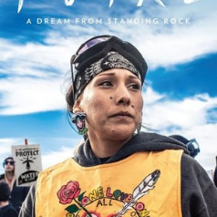
Severance. An Apple TV series. Audacious, mysterious, and bringing fresh insight into the perils of corporate drudgery. | 
1619 Project. A hulu series. Reframing the country's history by placing the consequences of slavery and the contributions of Black Americans at the very center of national narrative; the legacy of slavery shapes different aspects of contemporary American life. | 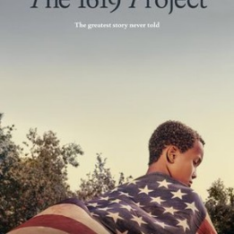
The Woman King. A remarkable story of the Agojie, the all-female unit of warriors who protected the African Kingdom of Dahomey in the 1800s with skills and a fierceness unlike anything the world has ever seen. Inspired by true events. | 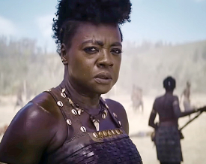
No Bears. Two parallel love stories in which the lovers are troubled by hidden, inevitable obstacles, the force of superstition and the mechanics of power. | 

Images were downloaded from Rottentomatoes.com. The synopses of the plot were extracted from Rottentomatoes.com
fd
d

Reflection Questions

Don’t treat these questions like “homework” or try to answer everyone. Instead, make time to meditate on the list and then pick the one question that speaks to you most. The goal is to figure out which question captures the call of your inner voice? Which one contains “your work”? And what is that question trying to get you to notice or acknowledge?

Often it helps to read the list to a friend or loved one and ask them which question they think is the question you need to wrestle with!

- How did your parents’ acts of resistance shape you?
- Has your resistance to change grown or eased as you’ve gotten older?
- What change in your life do you wish you had not resisted?
- Have you been following the path of least resistance for so long that you no longer notice??
- Is it time to heed the warning that “What you resist, persists”?
- What is problematic emotion is hardest for you to resist? Jealousy? Pessimism? Spite? Judgmentalism? Wanting to be right? Wanting to always win? (What is one thing you might do to get better at that?)
- How has art shaped and inspired your political resistance?
- Is life trying to lead you down a road you’ve long resisted?
- Is it possible that the form of resistance you need to take right now is rest?
- How good are you at resisting the tyranny of the to do list?
- Is your resistance animated by breath or by anger and despair alone?
- Are you resisting looking at a truth in your life right now?
- What’s your question? Your question may not be listed above. As always, if the above questions don't include what life is asking from you, spend the month listening to your days to find it.
Meditations, Prayers, & Blessings
[An asterisk (*) marks permissioned for online use.]

Prayer for Moving Forward *
Rev. Jennifer "Jo" VonRue
Full prayer at https://www.uua.org/worship/words/prayer/prayer-moving-forward
Permission Source

Our hearts are stretched thin. We see and hear the devaluing of people of color, of those with disabilities, of women, of immigrants; this list, incomplete as it is, is exhausting…
However thin our resilience may be wearing; we do not give up or give in…
We will not rest until we are heard.
We will not rest until equity is made more real…

For All That Is Our Life*
Rev. Liz Weber
Full piece at https://www.uua.org/worship/words/prayer/all-our-life
Permission Source

Spirit of Resistance,
help us to stick up for what is right,
even when we are tired or afraid.
Help us to dream of the world as it should be
and act to bring that world about…

History's Road *
Rev. Clyde Grubbs and Rev. Marjorie Bowens-Wheatley
Found in Voices from the Margins, UUA meditation manual & Soul Matters “Common Shelf” Book

Let It Be Done *
Rev. Dr. Monica Cummings
Found in Voices from the Margins, UUA meditation manual & Soul Matters “Common Shelf” Book

Meditation for Challenging Times *
Rev. Joan Javier-Duval
Full piece at https://www.uua.org/worship/words/meditation/meditation-challenging-times
Permission Source

Prayer for While in The Struggle *
Rev. Margalie Belizaire

Permission Secured by Soul Matters

Spirit of light and love, Spirit of resistance
Spirit of generosity,
That which serves as our conscience in this work
That we do to dismantle white supremacy
To empower the marginalized
To insist that black lives matter, matter
We have been angered
We have been saddened
We have been pushed to the brink once more
We are also inspired and seem resolved to do better this time
To not simply get to the other side of this moment
But to get there morally healthier
To get to a safer space for black bodies
Spirit, help us to understand that we each have a role in justice work
For our liberations are tied to one another's
Give us the clarity of mind to know what
our individual part is in the struggle
That there are many ways to protest injustice
Help us to find our way and commit to it
Spirits, we ask for guidance
Send us strength and endurance
Help us to give our all to this
And hold nothing back
For precious lives depend on it
We will be imperfect
Rest assured that we will mess up over and over again
And we must do it anyway.
May we summon the courage to tear down this system of injustice
And get busy creating a “world community with... justice for all.”
May it be so.
Amen

For Passover...

Desert Spring *
Rev. Victoria E Safford
Full piece found at https://www.uua.org/worship/words/meditation/desert-spring
Permission Source
…They had no idea where they were going, when they left that night, in the dark, without lights, without shoes, without bread, their children smothered against them so they would make no noise… They went into the wilderness. There they wandered forty years…
In the springtime we remember: the promised land is not a destination—it is a way of going. The land beyond the Jordan, that country of freedom and dignity and laughter—you carry it inside you all the while. It is planted in your mind and heart already, before you ever start out, before it even occurs to you that in order to leave that life in Egypt, the intolerable bondage of that life, what you need to do is stand up and walk forward.

For Earth Day...

Prayer of Co-Creation *
Rev. Lyn Cox
Full prayer at https://www.uua.org/worship/words/prayer/prayer-co-creation
Permission Source
Creative spirit, source of life and love:
Thank you for the breezes of change, clearing our heads...
Thank you for oceans of love, rivers of connection...
May we take this clay and co-create a new realm of justice and beauty…

Earth Teach Me
From the Ute native people of North America
Full piece at https://peopleandcultures.blog/2018/07/30/a-ute-prayer-earth-teach-me-to-remember/

Earth teach me courage
as the tree which stands all alone…

Earth teach me freedom
as the eagle which soars in the sky…

Earth teach me to remember kindness
as dry fields weep with rain.

Stories For All Ages

Picture Books

Horton Hears a Who, Dr. Seuss
The classic and beloved story on resistance: https://www.youtube.com/watch?v=B-i1E1UbwVI

Anh’s Anger by Gail Silver
Book: https://www.amazon.com/Anhs-Anger-Gail-Silver/dp/1888375949/
Video: https://www.youtube.com/watch?v=s7fLfnmvfB

What is the Vesak Festival & What Does it Mean to Buddhists? -
Video story told by Buddhist children: https://www.youtube.com/watch?v=U1pQwj-CNZ8

Peaceful Fights for Equal Rights by Rob Sanders
Book: https://www.amazon.com/Peaceful-Fights-Equal-Rights-Sanders/dp/1534429433/
Video: https://www.youtube.com/watch?v=GUeB_ocHMv8

The Easter Story by Brian Wildsmith
Book: https://www.amazon.com/Easter-Story-Brian-Wildsmith/dp/0802851894/
Video: https://www.facebook.com/watch/?v=529957774622191

The Whispering Town by Jennifer Elvgren
Book: https://www.amazon.com/Whispering-Town-Holocaust-Jennifer-Elvgren/dp/1467711950/
Read Aloud: https://www.youtube.com/watch?v=iHLVPqnrQvo

Exodus By Brian Wildsmith
Book: https://www.amazon.com/Exodus-Brian-Wildsmith/dp/0802851754/
Read Aloud: https://www.youtube.com/watch?v=JD3CmUCZ5LQ

We Are Better Together by Bill McKibben
Book: https://www.amazon.com/We-Are-Better-Together/dp/B094DS7MP6/
Video Read Aloud: https://www.youtube.com/watch?v=V3LaSiPTI3A (min. 3:35 - 6:45)

What a Waste by Jess French
Book: https://www.amazon.com/What-Waste-Recycling-Protecting-Planet/dp/1465481419/
Video Review: https://www.youtube.com/watch?v=Zj_Rn7CFQ24

Laila’s Lunchbox by Reem Faruqi (Author), Lea Lyon (Illustrator)
Book: https://www.amazon.com/Lailahs-Lunchbox-Ramadan-Reem-Faruqi/dp/0884484319/
Video: https://www.youtube.com/watch?v=rjZ_EpecEKk

Sometimes People March by Tessa Allen
Book: https://www.amazon.com/Sometimes-People-March-Tessa-Allen/dp/0062991183/
Read aloud by children: https://www.youtube.com/watch?v=DcGCcTDjUqA

That's Not My Name! by Anoosha Syed
Book: https://www.amazon.com/Thats-Not-Name-Anoosha-Syed/dp/059340517X/
Read Aloud: https://www.youtube.com/watch?v=Br9olcMJsjE

Rise Up and Write It by Nandini Ahuja
Book: https://www.amazon.com/Rise-Up-Write-Real-Posters/dp/0063029596/
Video: https://www.youtube.com/watch?v=-Hig3WhXcrw

Wisdom Tales
The Soul Matter team has heard that wisdom tales are especially important to the faith formation of our children. They serve as companions for our journeys, communicating and helping us hold on to timeless morals as we navigate not only childhood but adulthood as well.

Ethiopia: Fire Water Truth and Falsehood
China: The Stonecutter
Jewish: Partners, By Marc Gelman, found in Does God Have a Big Toe?
Aesop: The North Wind and the Sun
J. Jaworski: Weight of a Snowflake
Sufi: Tale of the Journeying Stream
North American: The Daffodil Principle

Recommended Wisdom Tales from “Doorways to the Soul” by Elisa Davy Pearmain
- Story #9 - How the Spider Symbol Came to the People (Osage Plains Indians, persistence)
- Story #13 - What is Heaven, What is Hell? (Zen, speaking truth to power)
- Story #22 - The Quail’s Song (Unknown, persistence as resistance)
- Story #35 - Only a Visitor (Hasidic; we are only visitors on planet earth)
- Story #47 - Feathers (Hasidic; change habits)
- Story #51 - You’re Still Carrying Her (Zen; center yourself to resist)

