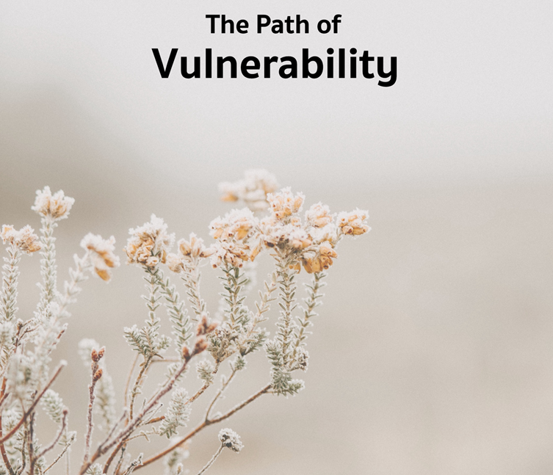

It may be that when we no longer know what to do
we have come to our real work,
and that when we no longer know which way to go
we have come to our real journey.
The mind that is not baffled is not employed.
The impeded stream is the one that sings.
~ Wendell Berry

Monthly Theme Resources March 2023

Calendar Connections: March 2023
Month | Women's History Month, Irish American Heritage Month
Feb. 22 – Apr. 6 | Lent (A humorous take)
Mar. 3 | National Day of Unplugging - first Friday of March
Mar. 6-7 | Purim begins (more here & here)
Mar. 8 | International Women's Day
 | Holi (more here and here)
Mar. 11 | James Reeb’s death (1965), more here and here.)
Mar. 13 | Susan B. Anthony's death
Mar. 14 | Pi Day
Mar. 15 | Everything You Think is Wrong Day
Mar. 17 | St. Patrick’s Day
Mar. 20 | Ostara, Vernal Equinox, Beginning of Spring, more here
Mar. 21-25 | Selma–Montgomery March (1965), more here
Mar. 22 | World Water Day
Mar. 22 – Apr. 21 | Ramadan, more here and here
Mar. 22 – Apr. 22 | Climate Justice Month
Mar. 25 | Tolkien Reading Day
 | Viola Liuzzo’s death (1965)
 | The Annunciation
Mar. 31 | International Transgender Day of Visibility, more here

Recommended Resources for Personal Exploration & Reflection

Word Roots & Definitions

“According to the Merriam-Webster Dictionary, the word vulnerability is derived from the Latin word vulnerare, meaning “to wound.” The definition includes “capable of being wounded” and “open to attack or damage.” Merriam-Webster defines weakness as the inability to withstand attack or wounding. Just from a linguistic perspective, it’s clear that these are very different concepts, and in fact, one could argue that weakness often stems from a lack of vulnerability—when we don’t acknowledge how and where we’re tender, we’re more at risk of being hurt.”
Brene Brown, from Daring Greatly

Wise Words

Vulnerability is the birthplace of love, belonging, joy, courage, and creativity. It is the source of hope, empathy, accountability and authenticity.
Brené Brown

Instead of asking ourselves, “How can I find security and happiness?” we could ask ourselves, “Can I touch the center of my pain? Can I sit with suffering, both yours and mine, without trying to make it go away? Can I stay present to the ache of loss or disgrace - disappointment in all its many forms - and let it open me?”
Pema Chodron

I have more compassion than if I had never been wounded or if I had never been betrayed or I had never been harmed… those disappointments have made me gentler with other people and their disappointments, the stuff that they have to carry around and endure.
Elizabeth Gilbert

Owning our story can be hard but not nearly as difficult as spending our lives running from it. Embracing our vulnerabilities is risky but not nearly as dangerous as giving up on love and belonging and joy—the experiences that make us the most vulnerable.
Brené Brown

Honestly, sometimes I don’t have the strength to be strong because I am truly tired of fighting. There are days I want to rip off this superwoman cape because I no longer see the point of being “a strong Black woman.” I am tired of the internal pain that I pretend doesn’t exist. Yes, I get tired of being resilient.
Dr. Carey Yazeed

The secret of vulnerability is not everyone is meant to know. Practice a sacred withholding. Stop giving all of you away.
Cole Arthur Riley

Tis a fearful thing to love what death can touch
Yehuda HaLevi

You will lose everything. Your money, your power, your fame, your success, perhaps even your memories… But right now, we stand on sacred and holy ground, for that which will be lost has not yet been lost, and realizing this is the key to unspeakable joy… Impermanence has already rendered everything and everyone around you so deeply holy and significant and worthy of your heartbreaking gratitude.
Loss has already transfigured your life into an altar.
Jeff Foster

It’s the backwards law in action: in order to become more resilient, more formidable, you must first bare your flaws and weaknesses for the world to see. In doing so, they lose their power over you.
Mark Manson

I imagine one of the reasons people cling to their hates so stubbornly is because they sense, once hate is gone, they will be forced to deal with pain.
James Baldwin

I’m beginning to realize that all of my big “negative” emotions - anger, intolerance, crankiness… the list goes on – have their root in my feeling vulnerable. So, I’ve been practicing feeling the vulnerability rather than the secondary feeling… If I’m able to say, “I’m feeling vulnerable,” rather than, say, “YOU’RE MAKING ME MAD,” then there is much more room for connection and healing.
Rev Megan Foley

It is an act of resistance in our culture to say: everyone needs care at different points in their life and everyone provides care to others.
rev emilie boggis

The difficult thing is that vulnerability is the first thing I look for in you and the last thing I'm willing to show you. In you, it's courage and daring. In me, it's weakness.
Brene Brown

Just because I’m feeling vulnerable doesn’t mean I am vulnerable... Often my feeling of vulnerability has much more to do with events from my past than it does with what’s happening now.
Rev Megan Foley

Self-revelation is the most vulnerable-making thing of which human beings are capable, and yet in that vulnerability we find our deepest freedom.
Maria Popova

Heartbreak is the beautifully helpless side of love and affection.
David Whyte

Faith minus vulnerability and mystery equals extremism. If you’ve got all the answers, then don’t call what you do ‘faith.’
Brene Brown

Grief is the necessary current we need to carry us into our next becoming… It rises on a salty geyser of tears, streaming down our cheeks until it moistens the soil where we stand, preparing us for new growth. Have you ever noticed how beautiful a person is after they’ve wept? It’s as if they are made new again by the baptism of tears.
Toko-pa

One of the most important things you can do on this earth is to let people know they are not alone.
Shannon L. Alder

Poetry

Sometimes it takes darkness and the sweet
confinement of your aloneness
to learn
anything or anyone
that does not bring you alive
is too small for you.
David Whyte

Before you learn the tender gravity of kindness
you must travel where the Indian in a white poncho
lies dead by the side of the road.
You must see how this could be you…
Naomi Shihab Nye

Videos & Podcasts

Got Climate Doom? Here’s What You Can Do to Actually Make a Difference
https://www.nytimes.com/2021/11/10/opinion/climate-change-personal-actions.html
On the argument about how to best address our vulnerability to climate crisis

Feeling Through
https://www.youtube.com/watch?v=h1CqzntEZZ8
Award winning short film on opening ourselves to the vulnerability of kindness and compassion.
Learn more about the film here and here

The Bengsons - Hope Comes
https://www.youtube.com/watch?v=K8AegG5en2g

The Power of Vulnerability, Brene Brown
http://www.youtube.com/watch?v=iCvmsMzlF7o

“The Myth of Normal,” Healing in a Toxic Culture & How Capitalism Fuels Addiction
https://www.youtube.com/watch?v=OvSL6RZCkyI
On a culture that leaves us vulnerable to trauma

The Unnerving Conclusions
https://www.nytimes.com/2022/10/28/opinion/ezra-klein-podcast-lynn-vavreck-john-sides.html
On the vulnerability of our politics

Men and Boys are Struggling. Should We Care?
https://podcasts.apple.com/ca/podcast/men-and-boys-are-struggling-should-we-care/id1081584611?i=1000589866749

Your Suffering is a Bridge, James Baldwin
https://www.instagram.com/reel/CeUUWaejNi-/?igshid=MDJmNzVkMjY%3D

Music

On Vulnerability (regular playlist)
Each month there is a playlist on the theme available on Spotify and YouTube music
- Spotify playlist here
- YouTube playlist here

Contemporary Music
Check out these popular songs that reflect the theme of vulnerability:
- Girls Like Us - Zoe Wees
- Down in a Hole - Alice in Chains
- Broken People - Logic
- Vulnerable - Evie Irie
- Beautiful Disaster - Kelly Clarkson
- Someone You Love - Lewis Capaldi
- Vulnerable - Selena Gomez
- Be Ok - Ingrid Michaelson
- Vulnerable - Secondhand Serenade
- Waterfalls - TLC
- Human - Christina Perri
- Lean On Me - Bill Withers
- The Keep Going Song - The Bengesons

Books

The Wild Edge of Sorrow: Rituals of Renewal and the Sacred Work of Grief
Francis Weller
Review: https://radicaldiscipleship.net/2017/04/19/the-wild-edge-of-sorrow/

You Are Your Best Thing: Vulnerability, Shame Resilience, and the Black Experience
edited by Tarana Burke & Brené Brown
https://www.amazon.com/dp/0593243625?tag=twentysomet05-20&linkCode=osi&th=1&psc=1
An anthology on vulnerability, shame, resilience, and the Black experience

Hunger
Roxane Gay
Review: https://www.newyorker.com/books/page-turner/roxane-gays-complicated-hunger

Of Boys and Men: Why the Modern Male Is Struggling
Richard Reeves
- Related article
- book review
- opinion column
- PBS interview
- podcast interview.

Movies & TV

Lucky. On the value of relationships and the vulnerability they require. Lucky follows the spiritual journey of a 90-year-old atheist and the quirky characters that inhabit his off the map desert town.
Aftersun. On the tender dance of parents and children showing their vulnerabilities to one another. At a fading vacation resort, 11-year-old Sophie treasures rare time together with her loving and idealistic father, Calum. Twenty years later, Sophie's tender recollections of their last holiday become a powerful and heartrending portrait of their relationship, as she tries to reconcile the father she knew with the man she didn't. | 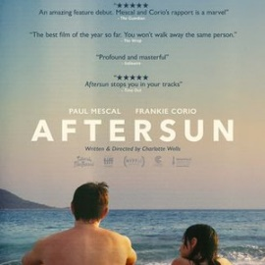
Mare of Easttown (HBO series). On the vulnerable truth that everyone you meet is fighting a battle you know nothing about. Small-town Pennsylvania detective Mare Sheehan investigates a murder as life crumbles around her.

Nomadland. On surviving in a nation that’s become hostile to ordinary citizens in need of help. A woman embarks on a journey through the American West after losing everything during the recession.

The Father. On the vulnerable path of dementia. Anthony is 80, mischievous, living defiantly alone and rejecting the careers that his daughter, Anne. Yet help is also becoming a necessity for Anne; she can't make daily visits anymore and Anthony's grip on reality is unraveling. THE FATHER warmly embraces real life, through loving reflection upon the vibrant human condition. | 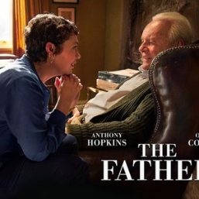
Requiem for the American Dream. On the vulnerability created by the modern concentration of wealth and power. Using interviews filmed over four years, Noam Chomsky discusses the deliberate concentration of wealth and power found in the hands of a select few.

Images were downloaded from Rottentomatoes.com. The synopses of the plot were extracted from Rottentomatoes.com
fd
d

Reflection Questions

Don’t treat these questions like “homework” or try to answer everyone. Instead, make time to meditate on the list and then pick the one question that speaks to you most. The goal is to figure out which question captures the call of your inner voice? Which one contains “your work”? And what is that question trying to get you to notice or acknowledge?

Often it helps to read the list to a friend or loved one and ask them which question they think is the question you need to wrestle with!

- Was vulnerability celebrated, encouraged, modeled, shamed or punished in your family of origin? How do you wish it had been treated?
- How would your life be different if you had trusted in vulnerability earlier in life?
- What has life taught you about leaps of faith and leaping into the unknown?
- Are you tired of pretending that you are strong?
- If asked, would your best friend be able to name your greatest fear? Your greatest failure? Your favorite thing about yourself? If not, is there work for you to do somewhere in that?
- Has vulnerability gotten easier or harder as you’ve grown older?
- What is your favorite failure? i.e., which of your failures ended up leading to unexpected success or to a gift?
- What’s one thing this month that you could do to stop hiding that truth you’re so scared to share?
- Are you good at asking for help?
- What’s your take on the often shared quote, “Hurt people hurt people”?
- What’s one thing this month you could do to address your fears about financial vulnerability?
- Has a past betrayal ever left you more protective than you need to be?
- Which kind of vulnerability scares you the most: Saying “I need help,” “This is me,” “I’m sorry,” “I’m tired,” “I disagree,” or “I like you.”
- How do you mask your vulnerability? What led to that form of protection? Are you sure it’s not doing more harm than good?
- As you look back over your life so far, what vulnerability story makes you smile?
- What’s your question? Your question may not be listed above. As always, if the above questions don't include what life is asking from you, spend the month listening to your days to find it.
Meditations, Prayers, & Blessings
[An asterisk (*) marks permissioned for online use.]

A Prayer of Risk *
Rev. Tamara Lebak
Full piece at https://www.uua.org/worship/words/prayer/prayer-risk

Today we remember
To breathe deeply…
To pause before we act…
And then to take in another deep breath poised on the edge
And risk jumping in…

Prayer for a Time in Need of Empathy *
Tanya Cothran
Full piece at https://www.uua.org/worship/words/prayer/prayer-time-need-empathy

God, teach us to consider also how others experience the world. To understand how my reality and their reality are different and yet they share qualities of the same core desire.

Teach us to listen for shared feelings, for places of connection…
Teach us to love into brokenness…

Let us be strong in our vulnerability
in our not-knowing,
in exposing our less-than-perfect scary bits, to those in front of us…

Gentleness in Living *
Rev. Richard S. Gilbert
Full piece at https://www.uua.org/worship/words/meditation/gentleness-living

…Our lives are like fragile eggs.
They crack and the substance escapes.
Handle with care!
Handle with exceedingly tender care
For there are human beings within,
Human beings as vulnerable as we are…

A Litany of Wholeheartednes *
Rev. Dawn Skjei Cooley
Full piece at https://www.uua.org/worship/words/reading/281512.shtml

Because we have not always had the courage to be imperfect
We let go of who we ought to be and embrace who we are…

Because we have been afraid of our own vulnerability
We let go of who we ought to be and embrace who we are…

Meditation/Prayer *
Rev. Jone Johnson Lewis

May we have the courage to open ourselves to the pleasures and wounds of life.
May we have the strength to be open and honest with ourselves and others even when it is difficult.
May we have the wisdom to understand that when we travel through the mist of uncertainty, openness and vulnerability make it more possible to find the way through that mist.
To be open and vulnerable is to be alive.

Sung Meditation - Everything Is Falling / Let It Fall
The Bengsons
https://www.youtube.com/watch?v=mDYe-QLN3Eg

When You Are Weary *
Jess Reynolds
Full piece found in Love Like Thunder, UUA meditation manual & Soul Matters “Common Shelf” Book
Spoken version here: https://www.facebook.com/watch/?v=374439230319660

The Advice *
Rev. Teresa I. Soto
Found in Spilling the Light, UUA meditation manual & Soul Matters “Common Shelf” Book

Stories For All Ages

Picture Books

The Rabbit Listened by Cori Doerrfeld
A touching tale on what we need most when we are feeling vulnerable.
Book: https://www.amazon.com/Rabbit-Listened-Cori-Doerrfeld/dp/073522935X/
Video: https://www.youtube.com/watch?v=rHPoj53dy8o

The Other Side by Jacqueline Woodson (Author), E. B. Lewis (Illustrator)
On the vulnerability of “crossing fences” that the world has put between us.
Book: https://www.amazon.com/Other-Side-Jacqueline-Woodson/dp/0399231161/
Video: https://www.youtube.com/watch?v=hdI0Q6MtZ_g

The Worry Box by Suzanne Chiew
Two animal friends use a Worry Box to help with anxiety and ask for help.
Book: https://www.amazon.com/Worry-Box-Suzanne-Chiew/dp/1848698305/
Video: https://www.youtube.com/watch?v=AAQKnQTzc3I

When Aiden Became a Brother by Kyle Lukoff
On the vulnerable path of being yourself and also learning how to love with your whole self.
Book: https://www.amazon.com/When-Aidan-Became-Brother-Lukoff/dp/1620148374/
Video: https://www.youtube.com/watch?v=yhPM8hcfECg

Beautifully Me by Nabela Noor
This book gets at the heart of the vulnerabilities that we can all sometimes face around self-esteem, healthy body image
Book: https://www.amazon.com/Beautifully-Me-Nabela-Noor/dp/1534485872/
Video: https://www.youtube.com/watch?v=1EBJZk_0pK0

The Book of Mistakes by Corinna Loyken
Being vulnerable means making mistakes.
Book: https://www.amazon.com/Book-Mistakes-Corinna-Luyken/dp/0735227926/
Video: https://www.youtube.com/watch?v=rYmYJxlSx7U

Wisdom Tales

- Buddhist: Overflowing Cup of Tea (Zen) (lose pride and be vulnerable to learn)
- Japanese Folktale: The Burning of the Rice Fields (being humble and knowing what is important)
- Christian: Loaves and Fishes (humility and trusting)
- China and India: The Water Carrier and the Cracked Pot. (Through our vulnerability we contribute beauty)
- Jewish: King Solomon and the Magic Ring (be vulnerable and humble as all things must pass)

Recommended Wisdom Tales from “Doorways to the Soul” by Elisa Davy Pearmain

This book is recommended as an addition to your library; however, due to copyright issues, only the story titles can be shared.
- Story #1 - The Monk and the Scorpion (Zen; vulnerable to each being’s nature)
- Story #16 - God Sends a Lifeboat (North American; asking for help)
- Story #19 - Casting the First Stone (Christian; who is without sin)
- Story #23 - The Lost Ticket (Nasruddin; don’t lose hope)
- Story #25 - The Castle Door (Original; relinquish pride to make a friend)

