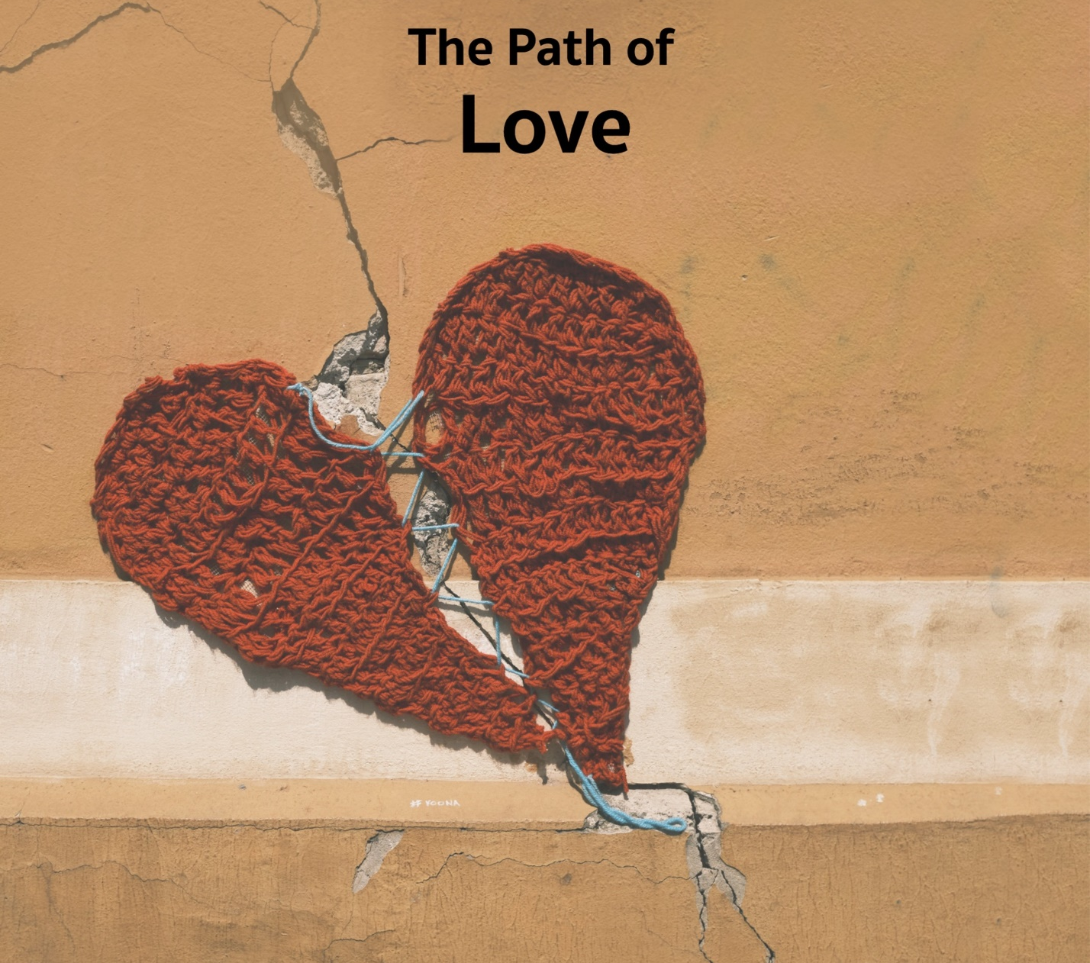

…this band of religious heretics…
talk of that love that will not let us go,
but they also ask, “Is our loving large enough?”
They ask that of us over and over again.

Monthly Theme Resources February 2023 | 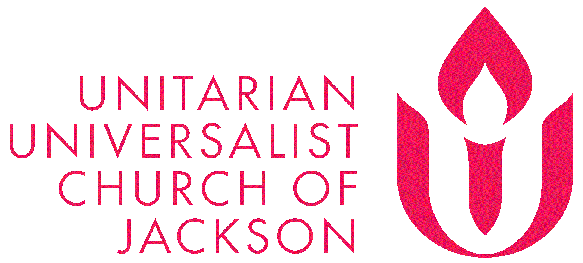

Calendar Connections: February 2023
Month | Black History Month (more here)
Jan. 15-Feb. 14 | Side with Love Campaign: Thirty Days of Love
Jan. 30-Apr. 4 | Season for Nonviolence, more here
Feb. 2 | Groundhog Day
Feb. 4 | Rosa Parks’ birthday (1930)
Feb. 5-6 | Tu BiShevat (Jewish), more here and here and here
Feb. 7 | National Black HIV/AIDS Awareness Day, more here and here
Feb. 12 | Fannie Barrier Williams’ birthday (1855)
Feb. 12 | Freedom to Marry Day
Feb. 12 | National Association for the Advancement of Colored People founded (1909)
Feb. 12 | Charles Darwin's Birthday/International Darwin Day
Feb. 14 | St. Valentine’s Day
Feb. 15 | Nirvana Day/Parinirvana Day -Buddha's entry into Nirvana (Buddhist)
Feb. 15 | Susan B. Anthony’s birthday (1820), more here; for information on her complex relationship to racism: here, here and here
Feb. 17 | Random Acts of Kindness Day, more here
Feb. 18 | The Edict of Torda is issued (1568)
Feb. 18 | Toni Morrison & Audre Lorde’s birthday, more here and here and here
Feb. 19 | President’s Day
Feb. 21 | Malcolm X assassinated (1965), related Netflix series here
Feb. 22 | Ash Wednesday (Christian), more here
Feb. 22-Apr. 26 | Lent (Christian), for a humorous take
Feb. 26 | Trayvon Martin is shot by George Zimmerman (2012)

Recommended Resources for Personal Exploration & Reflection

Word Roots & Definitions

“While the word love initially meant ‘find pleasing,’ it later took on associations with ‘praise,’ ‘trust,’ and ‘belief.’ Thus, the etymology and experience of love resemble each other quite closely…both are first about pleasure, later about admiration but finally about trust.” (source)

“Passion comes from the Latin word ‘pati,’ which means ‘to suffer.’ Your life's work is less about following a passion and more about your willingness to suffer along the way.” …having a passion doesn't mean you enjoy every aspect of it. It means the painful moments are ‘worth it’ because you value the reward above the pain.” (source)
11 Words That Come From “Love”
https://www.mentalfloss.com/article/61620/11-words-you-might-not-realize-come-love.

Wise Words

Your task is not to seek for Love, but merely to seek and find all the barriers within yourself that you have built against it.
Rumi

Love is what we are born with. Fear is what we learn. The spiritual journey is the unlearning of fear and prejudices and the acceptance of love back in our hearts.
Marianne Williamson

Loving you is like being 10 years old again, scaling a tree with my eyes bright and skyward, wanting only to get higher and higher, without a thought of how I would get back down.
Lang Leav

If you judge people, you have no time to love them.
Mother Teresa

Love takes off the masks that we fear we cannot live without and know we cannot live within. I use the word ‘love’ here not merely in the personal sense but as a state of being, or a state of grace—not in the infantile American sense of being made happy but in the tough and universal sense of quest and daring and growth.
James Baldwin

Love is the quality of attention we pay to things
J.D. McClatchy

When we understand love as the will to nurture our own and another’s spiritual growth, it becomes clear that we cannot claim to love if we are hurtful and abusive. Love and abuse cannot coexist.
Bell Hooks

If we really want to love we must learn how to forgive.
Mother Teresa

Never forget that justice is what love looks like in public.
Cornel West

There are days I drop words of comfort [and love] on myself like falling leaves and remember that it is enough to be taken care of by myself.
Brian Andreas

Never love anyone who treats you like you're ordinary.
Oscar Wilde

The only obsession everyone wants: ‘love.’ People think that in falling in love they make themselves whole? The Platonic union of souls? I think otherwise. I think you’re whole before you begin. And the love fractures you. You’re whole, and then you’re cracked open.
Philip Roth

I love you, not only for what you are, but for what I am when I am with you.
Roy Croft

Find those who tell you Do not be afraid, yet stay close enough to tremble with you. This is a love.
Cole Arthur Riley

How you love yourself is how you teach others to love you.
Rupi Kaur

We accept the love we think we deserve.
Stephen Chbosky

Loving only ourselves is escapism; loving only our opponents is self-loathing; loving only others is ineffective. All three practices together make love revolutionary, and revolutionary love can only be practiced in community.
Valarie Kaur

Perhaps everything terrible is, in its deepest being, something that needs our love.
Rainer Maria Rilke

I hope that one day you will have the experience of doing something you do not understand for someone you love.
Jonathan Safran Foer

Choosing love invites us to trust our inner knowing. To act upon it. Even when it isn’t rational. Even when you don't know what it means. I invite us to stop discounting our inner knowing. Breathe. Trust it as the voice of Love.
emilie boggis

Love can change a person the way a parent can change a baby—awkwardly, and often with a great deal of mess.
Lemony Snicket

Know that love is a vulnerability but not a weakness. Love is the volunteer in you that raises its hand and steps forward without needing to be rewarded. Love is a currency that functions in reverse, because the only way to be wealthy with it is to give more of it away.
Shane Koyczan

God is Love
1 John 4:8, The Bible

When they ask what you do for a living, say, I Love.
Jaiya John

Poetry

To love a person is to learn the song
That is in their heart,
And to sing it to them
When they have forgotten.
Arne Garborg

We have not come into this exquisite world
To hold ourselves hostage from love.
Run my dear,
From anything
That may not strengthen
Your precious, budding wings.
Hafiz

Love is the ultimate outlaw.
It just won’t adhere to any rules.
The most any of us can do is to sign on as its accomplice.
Tom Robbins

Even after all this time,
the sun never says to the earth,
“You owe me.”
Look what happens with a love like that.
It lights the whole sky.
Hafiz

love life…
Even when you have no stomach for it
and everything you’ve held dear
crumbles like burnt paper in your hands…
when grief weights you down like your own flesh…
Then you hold life like a face
between your palms…
and you say, yes, I will take you
I will love you, again.
Ellen Bass

How could I have known that over and over
you would crack the sky like lightning,
illuminating all my fears, my weaknesses, my sins.
Massive the burden this flesh
must learn to bear, like mules of love.
Ellen Bass, For My Daughter on Her Twenty-First Birthday

Videos & Podcasts

Why Romantics are Ruining Love
https://www.youtube.com/watch?v=R2v8TywXjLA

How Does Love Affect The Brain?
https://www.npr.org/2019/11/22/780960553/helen-fisher-how-does-love-affect-the-brain

A Queer Vision of Love and Marriage
https://www.ted.com/talks/tiq_milan_and_kim_katrin_milan_a_queer_vision_of_love_and_marriage?language=en

It Is Entirely Possible For A Black Girl To Be Loved, Ashley M. Jones
https://www.youtube.com/watch?v=Wy_XyUpIazU

How to Learn My Love Language
On sign language, spoken language & how love shows us what is possible
https://www.nytimes.com/2022/10/05/podcasts/modern-love-sign-language.html

When Love Arrives - spoken poetry
https://www.youtube.com/watch?v=cPG6nJRJeWQ&t=16s

Exit Strategy
https://www.thisamericanlife.org/779/ends-of-the-earth/act-one-9
A beautiful story of Alzheimers and letting go as a final act of love.

The Empathic Civilization, an animated talk
https://www.youtube.com/watch?v=l7AWnfFRc7g
On the challenges and necessity of extending love to all of humanity.

Free Hugs
https://www.youtube.com/watch?v=hN8CKwdosjE
Why don’t we all hand out love more freely?!

Music

Check out these popular songs that reflect the theme of wonder:
- At Last - Etta James
- All of Me - John Legend
- L-O-V-E - Nat King Cole
- Thousand Years - Christina Perri
- Addicted to Love - Florence + the Machine
- The Rose - Bette Midler
- Yellow - Coldplay
- Carried Me with You from Onward - Brandi Carlisle
- What I Did for Love from A Chorus Line - Hamlisch/Kleban

In addition to our regular playlist on the theme, we’ve created two other playlists on love: one of romantic love and another on the journey of a broken heart.

As always, each playlist is available on Spotify and YouTube music. And they are all organized as a journey, so consider listening from beginning to end and using them as musical meditations.

On Love (regular playlist)
- Spotify playlist here
- YouTube playlist here

Let Me Count the Ways (for sweethearts)
- Spotify playlist here
- YouTube playlist here

For a Broken Heart
- Spotify playlist here
- YouTube playlist here

Books

Extremely Loud & Incredibly Close
Jonathan Safran Foer
On love and grief

All About Love: New Visions
bell hooks
Related essay here

Tomorrow, and Tomorrow, and Tomorrow
Gabrielle Zevin
“Meditation on… the ways in which platonic love can be deeper and more rewarding—especially in the context of a creative partnership—than romance.” - The New Yorker

The Year of Magical Thinking
Joan Didion
On love and loss
Related essay here

Movies & TV
Call Me By Your Name: a melancholy, powerfully affecting portrait of first love – In the summer of 1983, precocious 17-year-old Elio Perlman is spending the days with his family at their 17th-century villa in Lombardy, Italy. He meets Oliver, a handsome doctoral student who's working as an intern for Elio's father. Amid the sun-drenched splendor of their surroundings, Elio and Oliver discover the heady beauty of awakening desire over the course of a summer that will alter their lives forever. | 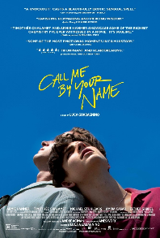
If Beale Street Could Talk: a beautifully filmed adaptation of James Baldwin's 1974 novel - In early 1970s Harlem, daughter and wife-to-be Tish vividly recalls the passion, respect and trust that have connected her and her artist fiancé Alonzo Hunt, who goes by the nickname Fonny. Friends since childhood, the devoted couple dream of a future together, but their plans are derailed when Fonny is arrested for a crime he did not commit. | 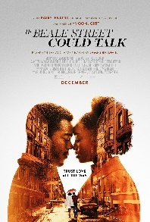
Once: A 2007 Irish musical romance film written and directed by John Carney. The film stars Glen Hansard and Markéta Irglová as two struggling musicians in Dublin, Ireland. Hansard and Irglová had previously performed music as the Swell Season, and composed and performed the film's original songs. | 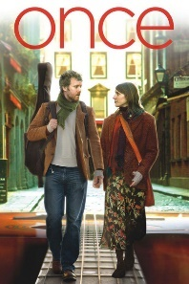
The Shape of Water: an unconventional love story - Set in 1962, a mute cleaning woman named Elise Esposito works the graveyard shift at a top-secret research facility with her close friend Zelda Fuller. While cleaning one night, Elise meets a human-like fish creature, who was brought to the facility following his discovery in South America to be studied for potential use against the Soviets. Elise falls in love with the creature and must fight to save him from the hands of the villainous Colonel Richard Strickland. | 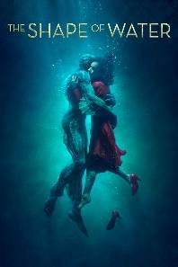
What They Had: After her ailing mother wanders off during a blizzard, Bridget returns to her childhood home in Chicago, accompanied by her rebellious daughter. Forced to referee between her father's stubborn insistence his wife remains at home and her equally determined brother's efforts to place her in a "memory care" facility, Bridget struggles to make sense of a lifetime of family conflict. With her mother's decline becoming increasingly obvious, long-simmering resentments bubble to the surface. | 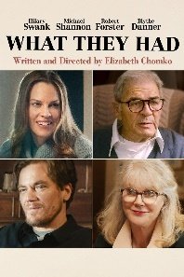
Fleishman Is in Trouble: Recently divorced 41-year-old Toby Fleishman dives into a brave new world of app-based dating with the kind of success he never had dating before he got married. But just at the start of his first summer of sexual freedom, his ex-wife Rachel disappears leaving him with 11-year-old Hannah and 9-year-old Solly and no hint of where she is or whether she plans to return. As he balances parenting, the return of old friends, a potential promotion, and all the eligible women Manhattan has to offer, he realizes he'll never be able to figure out what happened to Rachel until he can finally face what happened to their marriage in the first place. | 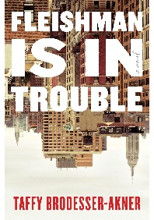

Reflection Questions
Don’t treat these questions like “homework” or try to answer everyone. Instead, make time to meditate on the list and then pick the one question that speaks to you most. The goal is to figure out which question captures the call of your inner voice? Which one contains “your work”? And what is that question trying to get you to notice or acknowledge?

Often it helps to read the list to a friend or loved one and ask them which question they think is the question you need to wrestle with!

- What did love mean to you as a child?

- How have you changed your mind about love?

- How has love changed as you’ve gotten older? Is it softer? Quieter? Larger? Tougher? Smaller? Sneakier? More central? More painful?

- Whose love has companioned you the longest?

- Has love ever made you smarter?

- Some say the opposite of love is not hate but indifference. Others say its opposite is fear. What do you say?

- Are you using your busyness to shield you from your heartbreak?

- Is it time to let someone know that your heart is broken?

- Is it time to offer “tough love”?

- Is it time to offer “sacrificial love”?

- Is someone trying to offer you love but you don’t notice it?

- Are you turning your back on love?

- Are you sacrificing too much in the name of love?

- What might it mean to regularly ask, “What would love do here?”

- Is love ever separate from the feeling of home?

- What’s your question? Your question may not be listed above. As always, if the above questions don't include what life is asking from you, spend the month listening to your days to find it.

Meditations, Prayers, & Blessings

Open Our Hearts With Love, Rev. Naomi King *
Full piece at https://www.uua.org/worship/words/reading/184319.shtml

When the world’s violence shatters the joy of a moment
We pause and reach out for the hands that remain
We open our hearts with love.
When despair rises as a monster from the deep and drags down one of our own, our answer is that
We open our hearts with love…

Power Prayer, Rev. Becky Brooks *
Full piece at https://www.uua.org/worship/words/prayer/power-prayer

Spirit of Life, I have witnessed
a loud love,
an out-loud love,
that challenges me.
I did not recognize it
at first—
the rumble of an ocean
I had long been under.
But here it is right now…
It doesn’t play nice…
This love demands…

The Home That Love Made, Rev. Amanda Poppei *

This is the home that love made.
It is full of the love that the founders felt, when they planned out these walls and raised these beams above us.
This is the home that love made.
It is full of the love of all who have worshiped here; those who have celebrated and grieved here; the babies dedicated, couples married, and family members mourned here.
This is the home that love made.
It is full of the love of our children, as they learn and laugh together, and our youth, as they grow into their own sense of purpose and meaning.
This is the home that love made.
It is full of the love of the staff who have served it, full of their hopes for this congregation, their hard work and their acts of dedication.
This is the home that love made.
It is full of the love of the choir, the love made so clear in the voices lifted here on Sunday morning.
This is the home that love made.
It is full of our love: the love of this community, despite our differences and our disagreements; the love that holds us together as a people.
This is the home that love made.
Can you feel it? May the love be with us always. Amen.

The Imprint of Love, Rev. Laura Horton-Ludwig *
Full piece at https://www.uua.org/worship/words/prayer/imprint-love

At times we may fear that love will not be strong enough.
At times we may question whether love really is at the root of all things,
in this world with so much struggle and suffering and discord.
We may struggle to hold on to our faith in love…

In the stillness and silence of our own heart
we read the imprint of love
created not by our own will,
but planted there for us to discover.
By what or whom, we cannot know, and yet it is there:
A clue,
a talisman,
a beacon,
a light within…

Embodied Love, What Does it Even Mean, roddy biggs *
Full piece found at https://drive.google.com/file/d/1U2EK9IM4T6uYB4Uit6Ltvb0iX7Rix3C8/view?usp=sharing

“This type of Love, Is Not a Love that we can simply name but a love that we must embody… We must embrace love, calling us forward, pushing us deeper within our bones and beings; a love that we must make known, not just by our words but by our actions…”

Psalm 23 for This Moment, Rev. Kevin Tarsa *
Full piece at https://www.uua.org/worship/words/affirmation/psalm-23-moment

…Just when the weight of the world I inhabit
threatens to drop me in place
and press my hope down into the ground beneath me
Love invites me to rest for a gentle while,
and leads the center of my soul to the quiet, still,
restoring waters nearby that,
somehow,
I had not noticed…

Hymn to Love: An All-Inclusive Valentine, Rev. Gary Kowalski *
Full piece at https://www.uua.org/worship/words/meditation/hymn-love-all-inclusive-valentine

For unrequited yearning
And the grand passion burning,
For quiet appreciation
And platonic contemplation…
For all that makes our pulses run,
Heart rates quicken
And keeps tickers tickin'...

Stories For All Ages

Picture Books

Love
Matt de la Peña (Author), Loren Long (Illustrator)
The many ways we experience the universal bond of love, which carries us from the day we are born throughout the years of our childhood and beyond.

Book: https://www.amazon.com/Love-Matt-Pe%C3%B1a/dp/1524740918

Video: https://www.youtube.com/watch?v=zwrA4UHL9_0

The Case for Loving: The Fight for Interracial Marriage
Selina Alko (Author, Illustrator), Sean Qualls (Illustrator)
Allowing all people to love who they love.

Book: https://www.amazon.com/Case-Loving-Fight-Interracial-Marriage/dp/0545478537

Video: https://www.youtube.com/watch?v=IkyPagSI1Rk

Dream Street
Tricia Elam Walker (Author), Ekua Holmes (Illustrator)
Love in a neighborhood filled with community.

Book: https://www.amazon.com/Dream-Street-Tricia-Elam-Walker/dp/0525581103

Video: https://www.youtube.com/watch?v=tDlWJH24rwQ (start at 3:14, end at 12:22)

Thank You, Omu
Oge Mora (Author)
A special recipe for red stew is shared, made with the heart.

Book: https://www.amazon.com/Thank-You-Omu-Oge-Mora/dp/0316431249

Video: https://www.youtube.com/watch?v=S628jnrp8JU

My Shadow is Purple
Scott Stuart (Author)
“...being true to yourself and moving beyond the gender binary” - Amazon - and being proud to love the things you love!

Book: https://www.amazon.com/My-Shadow-Purple-Scott-Stuart/dp/1922503819

Video: https://www.youtube.com/watch?v=JDLvFOk7E2Q

The Invisible Web: A Story Celebrating Love and Universal Connection (The Invisible String, 4)
Patrice Karst (Author), Joanne Lew-Vriethoff (Illustrator)
All of our strings to one another are interconnected in The Invisible Web. "It breathes as we breathe, pulsating all over our Earth, the single heartbeat of life and love. And do you know what that makes us all? One Very Big Family! This story can help us to see ourselves as a collective.

Book: https://www.amazon.com/Invisible-Web-Celebrating-Universal-Connection/dp/0316524964

Video: https://www.youtube.com/watch?v=tbQ7DM8QK_A

The Word Collector
Peter H. Reynolds (Author, Illustrator)
A collector shares his love of words.

Book: https://www.amazon.com/Word-Collector-Peter-H-Reynolds/dp/0545865026

Video: https://www.youtube.com/watch?v=NJ_MUs_MCkg (Read Aloud with the Obamas)

Hello Goodbye Dog
Maria Gianferrari (Author), Patrice Barton (Illustrator)
Love between humans and animals, featuring a brown girl in a wheelchair, but her race and disability are not the subjects of the story.

Book: https://www.amazon.com/Hello-Goodbye-Dog-Maria-Gianferrari/dp/1626721777

Video: https://www.youtube.com/watch?v=_Effaxacizw

Under the Love Umbrella
Davina Bell (Author)
Using an umbrella as a metaphor for love, acceptance, safety and comfort.

Book: https://www.amazon.com/Under-Love-Umbrella-Davina-Bell/dp/1925228207

Video: https://www.youtube.com/watch?v=urd8CaIHPLk

Wisdom Tales

- The Story of Kisa Gotami and the Mustard Seed (Buddhist)
  - By accepting death we love life
- The Edict of Torda (Unitarian Universalist)
  - A tale about religious tolerance
- The Platinum Rule, by Dave Kerpen
  - A tale about showing love and understanding for others
- The King’s Highway
  - A tale abou making the road smoother for those who follow
- The Perfect Heart (and here)
  - A tale by Pria Sher about a young heart vs. a heart with scars
- Map of the World (Jewish), told by Rev. Gretchen Haley

Try To Love A Stone
  - A wonderful story about the sacred work of loving the world
  - Note: it has heteronormative aspect at the end of the story that will need to be altered.

Red Bubble Letters, Rev. Misha Sanders
  - “I was even more dismayed that my artistic creation did not seem to be fading despite her vigorous attempt… Turns out, that red chalk that was — in my defense — on the chalk tray was actually a stumpy little red crayon… I was definitely in big trouble…I was mortified, that is, only until that beautiful, wise Sunday School teacher scooped me into her arms in a clear moment of amazing grace. I heard her deep, alto laugh in my ear, and she said, “Oh, no! No one is in trouble! Don’t you see, dear children, this is just perfect! What can erase God’s love? Nothing!””
- Doorways to the Soul, by Elisa Davy Pearmain
  - Story #2 - The Good Samaritan (love your neighbor)
  - Story #13 - What is Heaven; What is Hell (love in community)
  - Story #26 - Old Joe and the Carpenter (building bridges of love)
  - Story #31 - Love Dogs (be a love dog, longing for connection)

