UUCJ Family Monthly Packet

Welcome to the UUCJ Family Packet for the month of December 2019! This month we’re looking at the many ways our UU faith invites us to become “A People of AWE.” Each week we will explore the various ways we come to feel awe!

Week 1. Awe that Arises from Love in Action (Rosa Parks)
Week 2. Awe that Arises from Slowing Down (Transition from Autumn to Winter)
Week 3. Awe that Arises from Looking at the Night Sky (Yule/Solstice)
Week 4. Awe that Arises from Noticing New Life (Christmas)
Week 5. Awe that Arises from Looking into Each Other’s Eyes (Hanukkah)

Calendar Connections
- Monthly: Drunk/Drugged Driving Prevention Month and Seasonal Depression Awareness Month
http://www.soberforever.net/drunk-driving-infographic.cfm
http://www.cnn.com/2017/04/27/health/drugged-driving-death-rates-report/index.html
http://www.hopkinsmedicine.org/sebin/b/h/seasonal-depression-infographic.jpg
- Advent (Christian) Dec. 1-24
https://www.youtube.com/watch?v=QSsMq6UXXwo&list=RDfwssGB1RZvo&index=28
http://www.christianity.com/christian-life/christmas/what-is-advent.html
https://www.youtube.com/watch?v=cXLo-olvNv4&list=RDfwssGB1RZvo&index=28
- World AIDS Day - Dec. 1
https://en.wikipedia.org/wiki/World_AIDS_Day
https://www.uua.org/lgbtq/blog/december-1st-world-aids-day-call-recommit-ending-aids
- Rosa Parks Arrested - Dec. 1 (1955)
http://i.huffpost.com/gen/1602079/images/o-ROSA-PARKS-facebook.jpg
- International Day of Persons with Disabilities - Dec. 3
http://www.un.org/en/events/disabilitiesday/
- Chalica (UU) Dec. 3-9
https://www.uua.org/worship/holidays/chalica
https://www.uuworld.org/articles/chalica-gains-adherents
- Human Rights Day - Dec. 10
http://www.un.org/en/events/humanrightsday/
- Nobel Prize Day - Dec. 10
https://www.nobelprize.org/nobel_prizes/lists/all/
- Anniversary of Sandy Hook Shootings - Dec. 14
http://people.com/crime/sandy-hook-shooting-anniversary-parents-plans/
- How the Grinch Stole Christmas shown for first time - Dec. 18 (1966)
http://www.todayifoundout.com/index.php/2014/12/day-history-december-18th-grinch/
- Yule/Winter Solstice (Pagan/Wiccan) - Dec. 21
https://www.thoughtco.com/about-yule-rituals-2562970
- Montgomery's buses are desegregated - Dec. 21 (1956)
http://www.tolerance.org/sites/default/files/documents/Bus_Integration.pdf
- Hanukkah (Jewish) - Dec. 22-30
https://www.youtube.com/watch?v=-6FBX53ZblU
http://www.chabad.org/multimedia/media_cdo/aid/3157716/jewish/The-Hidden-Message-of-Chanukah.htm
https://www.youtube.com/watch?v=Z35dI01fouw
- Festivus for the rest of us - Dec. 23
https://www.daysoftheyear.com/days/festivus/
http://festivusweb.com/
- Christmas Eve - Dec. 24 (Tuesday)
- Christmas Day - Dec. 25 (Wednesday)
- Boxing Day (Canada) - Dec. 26
https://www.timeanddate.com/holidays/canada/boxing-day
https://www.huffingtonpost.ca/2013/12/24/what-is-boxing-day_n_4498366.html
- Kwanzaa - Dec. 26-Jan. 1
https://www.thoughtco.com/kwanzaa-seven-principles-45162
https://www.thoughtco.com/what-is-kwanzaa-2834584
- Copyright registration of Star Trek theme song - Dec. 27 (1966) - Star Trek is credited with the first interracial kiss on prime-time television in the US and the first African American actor in a main character on prime time
https://www.youtube.com/watch?v=hdjL8WXjlGI
- Holy Innocents Day (Christian) - Dec. 28
http://www.holidayscalendar.com/event/holy-innocents/
- Watch Night/Freedom’s Eve (Christian) - Dec. 31
http://www.beliefnet.com/faiths/christianity/articles/what-watch-night-really-means-for-people-of-faith.aspx

Honoring UU Identity

UU History & Historical Figures

Charles Dickens, British Unitarian who “saved” Christmas
Ebenezer Scrooge’s conversion in Charles Dickens’s novel reflects the central ideas of nineteenth-century Unitarianism (https://www.uuworld.org/articles/scrooges-conversion). Read more about Dickens on the Famous UU’s site: http://uudb.org/articles/charlesdickens.html

Favorite UU Wisdom Tales
- A Christmas Carol by Charles Dickens
https://en.wikipedia.org/wiki/A_Christmas_Carol
First published in 1843, this novella recounts the story of Ebenezer Scrooge, an elderly miser who is visited by the ghost of his former business partner Jacob Marley and the spirits of Christmas Past, Present, and Yet to Come. After their visits, Scrooge is transformed into a kinder, gentler man.
Dickens wrote A Christmas Carol during a period when the British were exploring and re-evaluating Christmas traditions, including carols and newer customs such as Christmas trees. British Unitarian Charles Dickens was influenced by the experiences of his own youth and by the Christmas stories of other authors including Washington Irving and Douglas Jerrold. Dickens had written three Christmas stories prior to the novella and was inspired following a visit to the Field Lane Ragged School, one of several establishments for London's street children. A Christmas Carol captured the zeitgeist of the mid-Victorian revival of the Christmas holiday. Dickens had acknowledged the influence of the modern Western observance of Christmas and later inspired several aspects of Christmas, including family gatherings, seasonal food and drink, dancing, games and a festive generosity of spirit.”
Theme Connection: The treatment of the poor and the ability of a selfish man to redeem himself by transforming into a more sympathetic character are the key themes of the story.

Beloved UU Liturgy
- Singing the Living Tradition #616 - For So the Children Come
Theme Connection: “Each night a child is born is a holy night…”
- Singing the Living Tradition #55 - Dark of Winter
Theme Connection: Awe that arises in the darkness of winter.
- Singing the Living Tradition #225 - O Come, O Come, Emmanuel
Theme Connection: “..to render every act with care. Rejoice, Emmanual shall come within as Light to Dwell.” Awe that arises with the hope of new life
- Singing the Living Tradition #230 - Duermete, Niño Lindo
Theme Connection: “... Sleep now, holy baby, with your head against my breast” Awe of new life.

Recommended Books

Rosa by Nikki Giovanni (Author), Bryan Collier (Illustrator)
https://www.youtube.com/watch?v=uiHNJK5vZXQ (video read aloud)
https://www.amazon.com/Rosa-Nikki-Giovanni/dp/0312376022
“Fifty years after her refusal to give up her seat on a Montgomery, Alabama, city bus, Mrs. Rosa Parks is still one of the most important figures in the American civil rights movement. This tribute to Mrs. Parks is a celebration of her courageous action and the events that followed. Award-winning poet, writer, and activist Nikki Giovanni's evocative text combines with Bryan Collier's striking cut-paper images to retell the story of this historic event from a wholly unique and original perspective.”
Theme Connection: We experience awe from the possibilities of change as illustrated in this real-life story. Imagine the Winter Holiday season for Rosa and the Black people of Montgomery. Mrs. Parks was arrested on Dec. 1, 1955. The buses were desegregated by court order on Dec. 21, 1956, 381 days later.

The Way to Start a Day by Byrd Baylor (Author), Peter Parnall (Illustrator)
https://www.amazon.com/Way-Start-Day-Byrd-Baylor/dp/0689710542
Description: “Beautiful paintings highlight the ways various peoples from around the world welcome the sun and the start of a new day in this Caldecott Honor–winning picture book.”
Theme Message: The sunrise gives us a sense of awe. What would it be like to treat the beginning of each day with awe and wonder?

I’m in Charge of Celebrations by Byrd Baylor (Author), Peter Parnall (Illustrator)
https://www.amazon.com/Charge-Celebrations-Aladdin-Picture-Books/dp/0689806205
Description: “a girl…shares her love for desert life as she tells of treasured experiences like dancing in the wind on Dust Devil Day or sleeping outside on a hot summer night during The Time of the Falling Stars.”
Theme Message: These are moments of awe which combine to create “a joyous celebration of the human spirit.”

The Stuff of Stars (The 2019 Coretta Scott King Illustrator Award Winner) By Marion Dane Bauer (Author), Ekua Holmes (Illustrator)
https://www.youtube.com/watch?v=XZy90Gn8aQ (video to give you an idea of the book)
https://www.amazon.com/Stuff-Stars-Marion-Dane-Bauer/dp/076367883X
“Before the universe was formed, before time and space existed, there was . . . nothing. But then . . . BANG! Stars caught fire and burned so long that they exploded, flinging stardust everywhere. And the ash of those stars turned into planets. Into our Earth. And into us. In a poetic text, Marion Dane Bauer takes readers from the trillionth of a second when our universe was born to the singularities that became each one of us, while vivid illustrations by Ekua Holmes capture the void before the Big Bang and the ensuing life that burst across galaxies. A seamless blend of science and art, this picture book reveals the composition of our world and beyond — and how we are all the stuff of stars.”
Theme Message: Contemplating the vastness of the universe and our place in it gives us goose bumps. We are each made of stardust

Refuge (UN refugee agency, USA for UNHCR) by Anne Booth (Author), Sam Usher (Illustrator)
https://www.youtube.com/watch?v=2prB_fqwbnI (video to give you an idea of the book)
https://www.amazon.com/Refuge-Anne-Booth/dp/0857637711
“Everyone may already know the story of how Jesus was humbly born in a manger, but Refuge is a lyrical depiction of what came next: the new family's travels through the desert, fleeing Herod's soldiers in order to find a safe place to welcome their son into the world. A poetic and refreshing look at the classic Christmas story that's never been more relevant, Refuge asks readers to consider the modern-day implications of being forced to flee your home country.”
Theme Message: The awe of the simple story of a newborn, whose family is forced into a journey and the kindness of strangers.

The Everything Seed (out of print but used copies are available) by Carole Martignacco (Author), Joy Troyer (Illustrator)
https://www.youtube.com/watch?v=nD9gnKmuQY8 (video to give you an idea of the book)
https://www.amazon.com/Everything-Seed-Carole-Martignacco/dp/0981724442
“From a single seed cradled and nourished in the rich soil of space, comes the entire universe...and even you! The Everything Seed is a new myth for a new generation, one that explains to the youngest child where we, and the world around us, originated. This joyous celebration of the origins of life is told through captivating poetry and luminous artwork. A gentle look at the Big Bang for young children. Incredible batik artwork.” The author, Carole Martignacco, is a U.U. minister. Joy Troyer’s illustrations are batik printed and with both sarongs and projected illustrations.
Theme Connection: We experience awe when we contemplate the vastness of the universe.

Recommended Movies

The True Meaning of Crumbfest
https://www.youtube.com/watch?v=Scsnf4EYMpo (video)
https://www.amazon.com/True-Meaning-Crumbfest-David-Weale/dp/0969860641 (book)
“Winner of the Ann Connor Brimer Award for Children's Literature; over 17,000 copies in print; animated Christmas special on TELETOON, with the spin-off series Eckhart The True Meaning of Crumbfest is the story of a curious little mouse named Ekhart, who sets off to discover the truth about that most abundant time of year called ""Crumbfest,"" when bounteous crumbs miraculously appear in the old Prince Edward Island farmhouse in which he lives. ... this a heartwarming tale of the magic that happens when the “Outside” and the “Inside” come together."
Theme Connection: The wonder and awe of kindness.

March On! The Day My Brother Martin Changed the World
https://www.commonsensemedia.org/movie-reviews/march-on-the-day-my-brother-martin-changed-the-world
This collection manages to explain how black people were treated unequally in a way even preschoolers should understand on a basic level. Those unfamiliar with Scholastic's Storybook Treasures series should be aware that these are animated adaptations of books; they're old-school narrations (often by the authors themselves or celebrities, in this case Lynn Whitfield, Michael Clarke Duncan, and writer Nikki Giovanni) accompanied by the books' illustrations and some historical photographs. That said, the March On! collection is a perfect introduction to the civil rights movement and black history for young kids. The four easy-to-follow stories all depict a time in American history when African Americas were treated either as chattel or second-class citizens

The Rosa Parks Story

https://www.imdb.com/title/tt0293562/
“In this film made three years before her death at 92, Rosa Parks was given a most accurate portrayal of her life and the times she grew up in. One simple act of disobedience to an unjust and demeaning law sparked the conscience of the caring members of a nation. Many people do not know much about Rosa Parks other than that act on Christmas Eve of 1955 when she refused to give up a seat on a bus to a white person because the Jim Crow laws demanded it. Rosa Parks, born Rosa Louise McCauley in the area around Montgomery, Alabama was quite politically aware. Part of that came from her marriage to barber Raymond Parks played here by Peter Francis James. It may have looked like an ordinary black barbershop to a lot of people, but in fact it was a meeting place for what was deemed revolutionary activity by the segregationists in control. You could find all kinds of radical literature there, not on public display to be sure, but stuff put out by the NAACP and even the Communist Party. When Raymond had met and was courting Rosa in 1932 he was raising money for the Scottsboro case, the notorious case where several black homeless youths riding in a freight car during the depression, allegedly gang raped some white women who were in similar economic circumstances. Rosa was not only a seamstress but also the secretary of the Montgomery chapter of the NAACP. She answered the call for justice not only on that night but also had a history of civil rights activism. In the film, Angela Bassett does a fine job in capturing the hopes and dreams and frustrations of a woman who saw and wanted a lot more from life than what she was restricted to. You'll also see Dexter King play his father Martin Luther King who first came to prominence during the boycott of the Montgomery Bus System that resulted from Rosa's arrest and fine. It's now 64 years since Rosa Parks made a defiant act against injustice the symbol of the Civil Rights movement. The Rosa Parks Story is an absolute must for any young viewers who want to acquaint themselves with a triumph against an unjust way of life.” - IMDB
Theme Connection: It is with wonder and awe that we come to understand the way Rosa Parks action sparked the conscience of the nation.

Recommended Family Discoveries/Activities

Ancient Earth Interactive Map
Type in your address and how many millions of years ago you wish to see and view an interactive online map of what the earth looked like.
https://www.smithsonianmag.com/smart-news/map-lets-you-plug-your-address-see-how-neighborhood-has-changed-over-past-750-million-years-180971507/#clVUBGlv6f6VQsqA.01

Beeswax Candles for Winter Nights
Purchase a kit or order beeswax sheets and wicks.
https://www.amazon.com/Make-Your-Own-Beeswax-Candle/dp/B004Q07P4E
https://www.thesprucecrafts.com/rolled-beeswax-candles-517038

Chalice Snowflakes

From Worship Web
https://www.uua.org/worship/words/image/chalice-snowflake-instructions
PDF Template to print out: https://assets.uua.org/sites/live-new.uua.org/files/paper_chalice_snowflake_instructions.jpg

Recommended For Parents

Celebrating the Winter Holidays by Michelle Richards, UU World
https://www.uuworld.org/articles/celebrate-winter-holidays

Pinterest Page
Check out the RE Soul Matters Pinterest page on Awe with images and links to the books, videos, activities and more as mentioned in this packet: https://www.pinterest.com/soulmattersre/2019-awe-december/

Inspiration Facebook Page
Get spiritual nourishment and inspiration by joining the Soul Matters Inspiration Facebook Page: https://www.facebook.com/soulmatterssharingcircle/

Soul Matters Spotify Music Playlists:
Discover musical inspiration on each of our monthly themes through our playlists:
https://www.soulmatterssharingcircle.com/spotify-lists.html

Share Your Ideas for the Monthly Packets!
If you come across something that would be great for any of our upcoming themes, send it our way at:

January: Integrity
February: Resilience
March: Wisdom
April: Liberation
May: Thresholds
​June: Play

Special thanks to all the Soul Matters RE Packet Author and Support Team:
- Packet Author: Katie Covey, Soul Matters Director of Religious Education
- Rev. Michelle Collins, Soul Matters Small Group & Special Projects Researcher
- Rev. Scott Tayler, Soul Matters Team Lead

Also thanks to the Soul Matters Religious Educators who send in suggestions for our monthly packets
and participate in our monthly packet brainstorming calls.

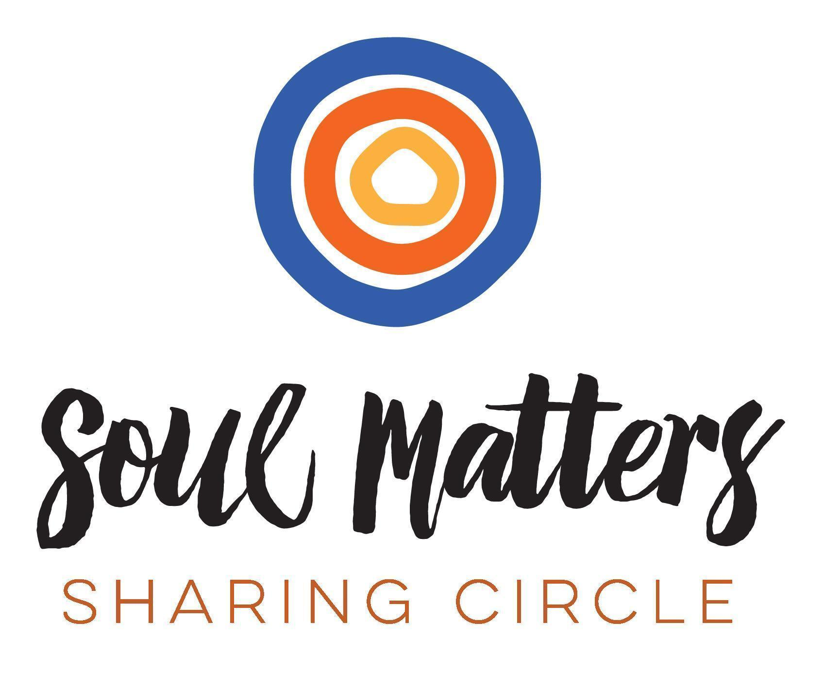
© 2019-20 Soul Matters ALL RIGHTS RESERVED

